2/29/2016

Simon Light

UTC Reading

Assignment 2

Unit 2

Contents

P5 – Set up standalone computer system 2

Introduction 2

Health and safety 2

CPU 3

RAM 7

Software 9

P6 – Configure a computer to a user’s need 11

Power saving options 11

Screen resolution 14

Desktop theme 15

Font size 18

Default language 20

P7 – Test a configured computer 22

P8 – Routine maintenance 22

Restocking printer 22

Paper 22

Ink 22

Defragging disk 22

M3 – Evaluate performance of a computer 23

D2 – Explain and justify improvements to a computer 23

Copyright Law 23

Limitations imposed by copyright 23

Prevention of software piracy 23

Legal implication of using and editing images 23

Where to find free images 23

Appendix 24

# P5 – Set up standalone computer system

## Introduction

I was tasked to set up a standalone computer. I was given a computer that was not functioning and asked to diagnose and fix any issues found.

## Health and safety

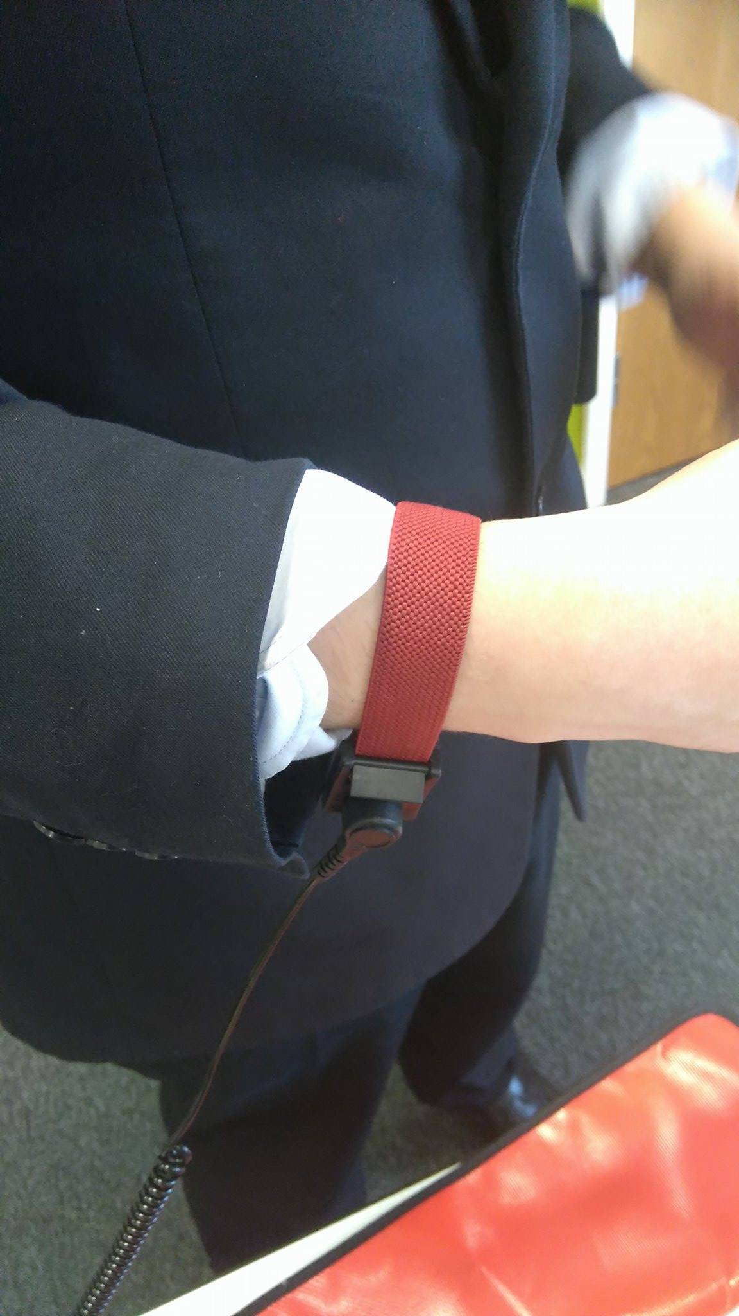

We started by finding a place in the room that was clear and away from any electronics. We then placed an anti-static mat on the table and connected ourselves to the mat via the band shown above.

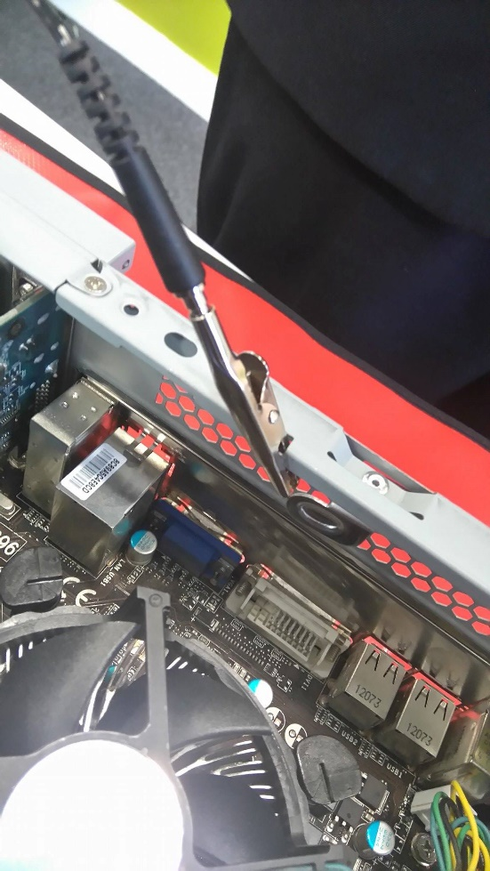

We then went and got the computer we were required to work on and placed it onto the mat. After removing the side panel we attached the antistatic mat to the computer via the crocodile clip shown above. Completing the circuit between the computer, the mat and myself meant that no electricity could be passed between myself and the computer. This removes the risk of damaging sensitive components.

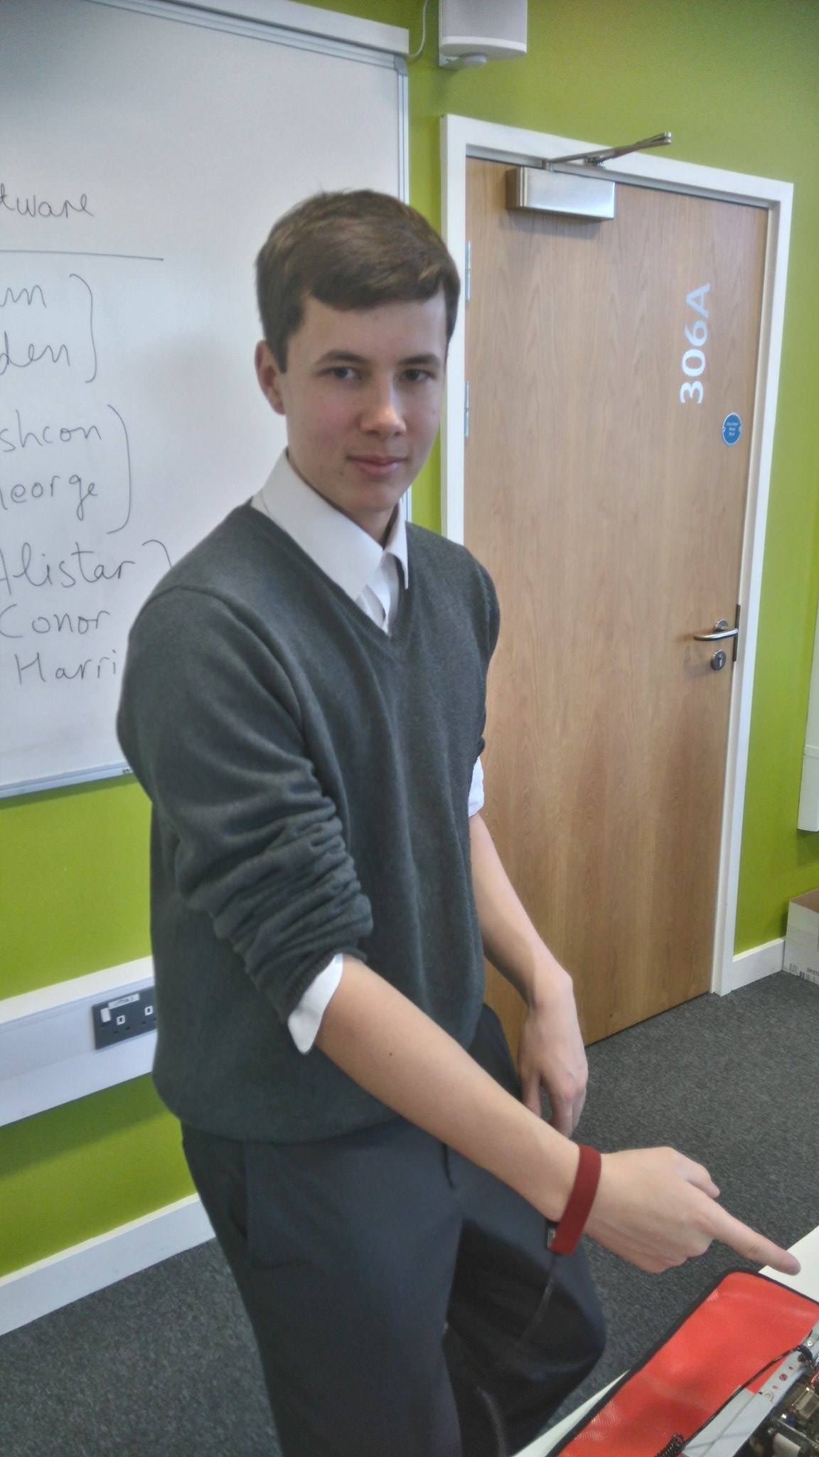

I then made sure that all loose pieces of clothing were removed. This included lanyards, rolling sleeves up, tie etc. Doing this mean that nothing would touch computer hardware other than my hands. This again would prevent against damaging sensitive components. It would also prevent any piece of clothing being caught in the fan, possible damaging it or you.

## CPU

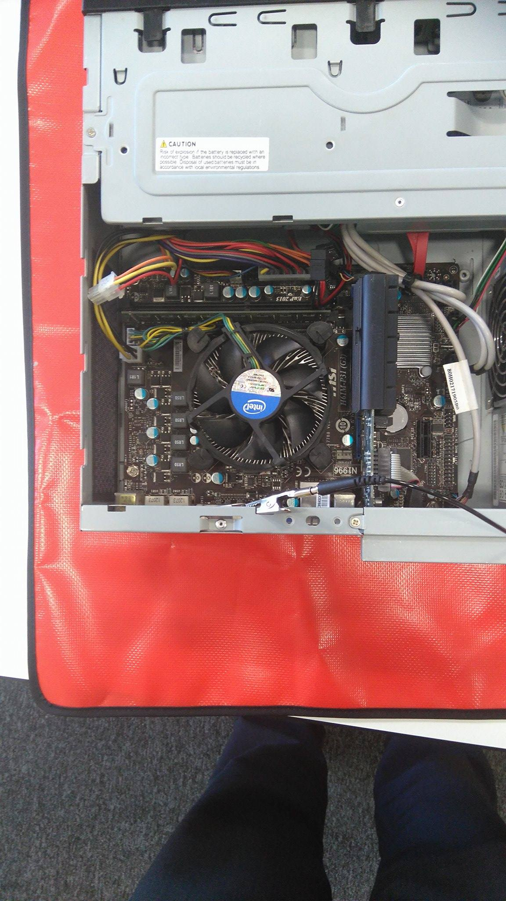

On opening the computer this is what we found. We noticed that one of the pins on the CPU heat sink was not in properly. Due to this we decided to remove it entirely and reinstall it.

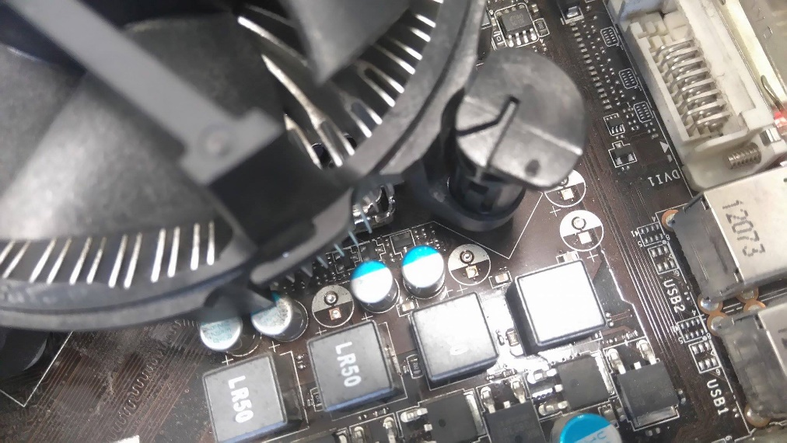

This is the pin that was loose.

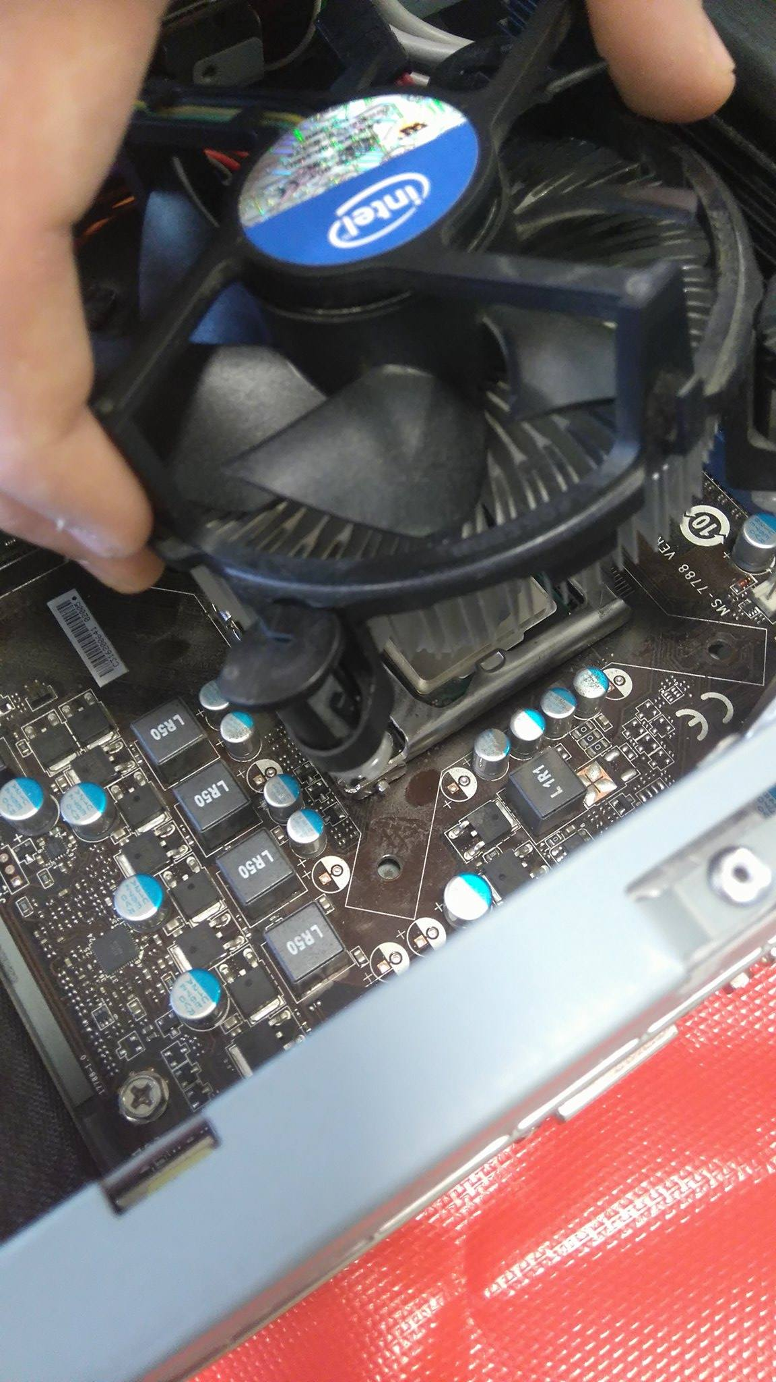

After loosening each of the pins individually, by twisting and then pulling, I then removed the heat sink.

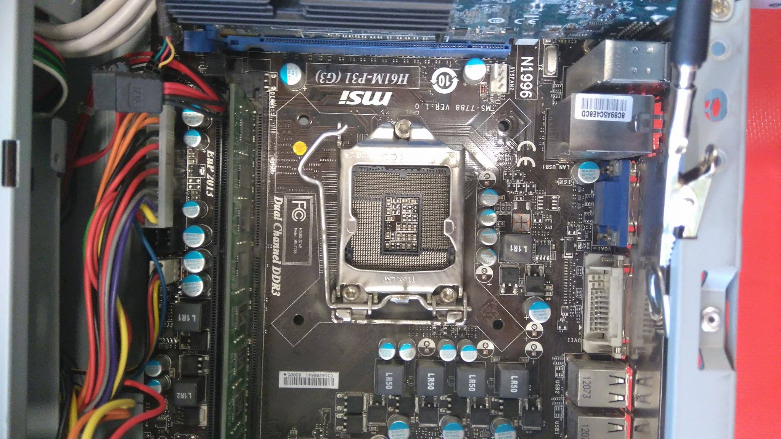

After removing the heat sink we discovered that there was no CPU on the motherboard. This was discovered as one of the issues with the computer.

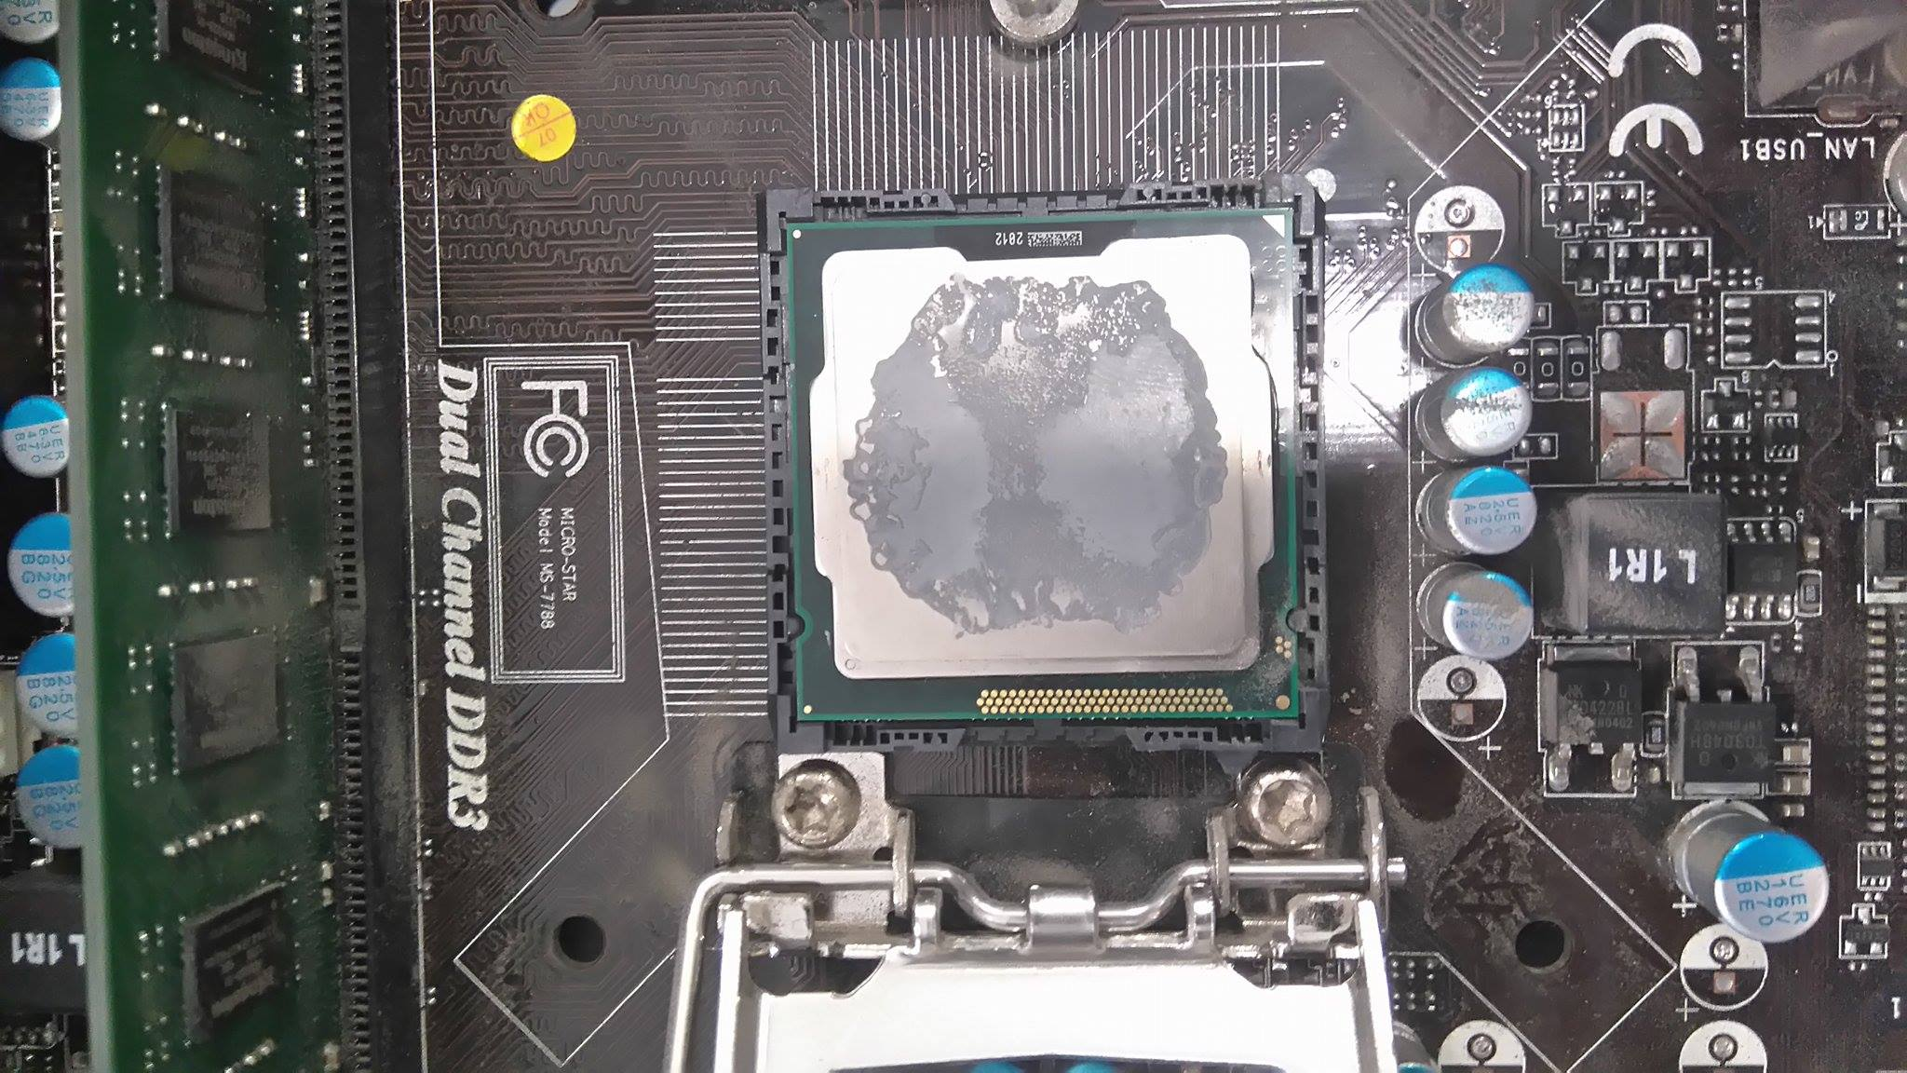

To rectify this error we opened the socket by lifting the retention arm. We then found a CPU that matched the socket type that we had on the motherboard. We then placed the chip in the socket making sure that we lined up the notches with the holes on the socket and CPU.

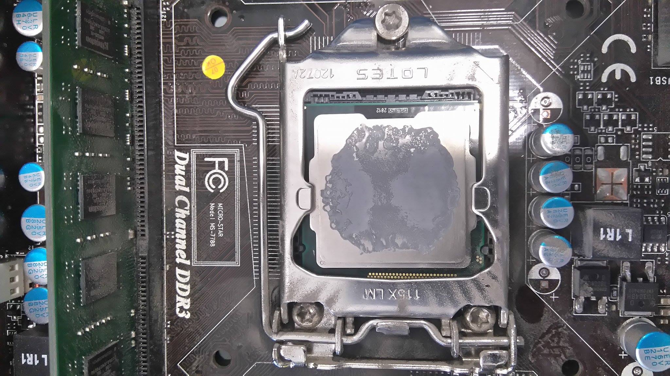

I then lowered the retention arm and slid it into its holder pin. This ensured a strong connection between the CPU and the Motherboard.

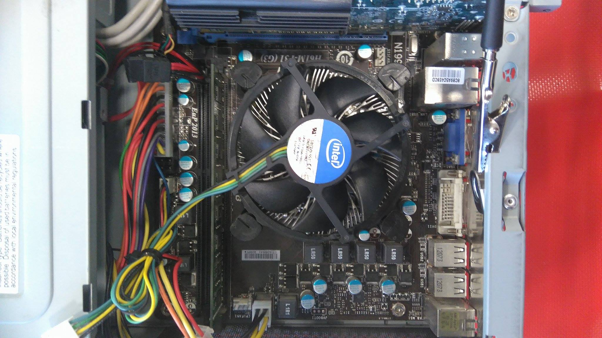

We then placed the heat sink back on the board and tightened the pins.

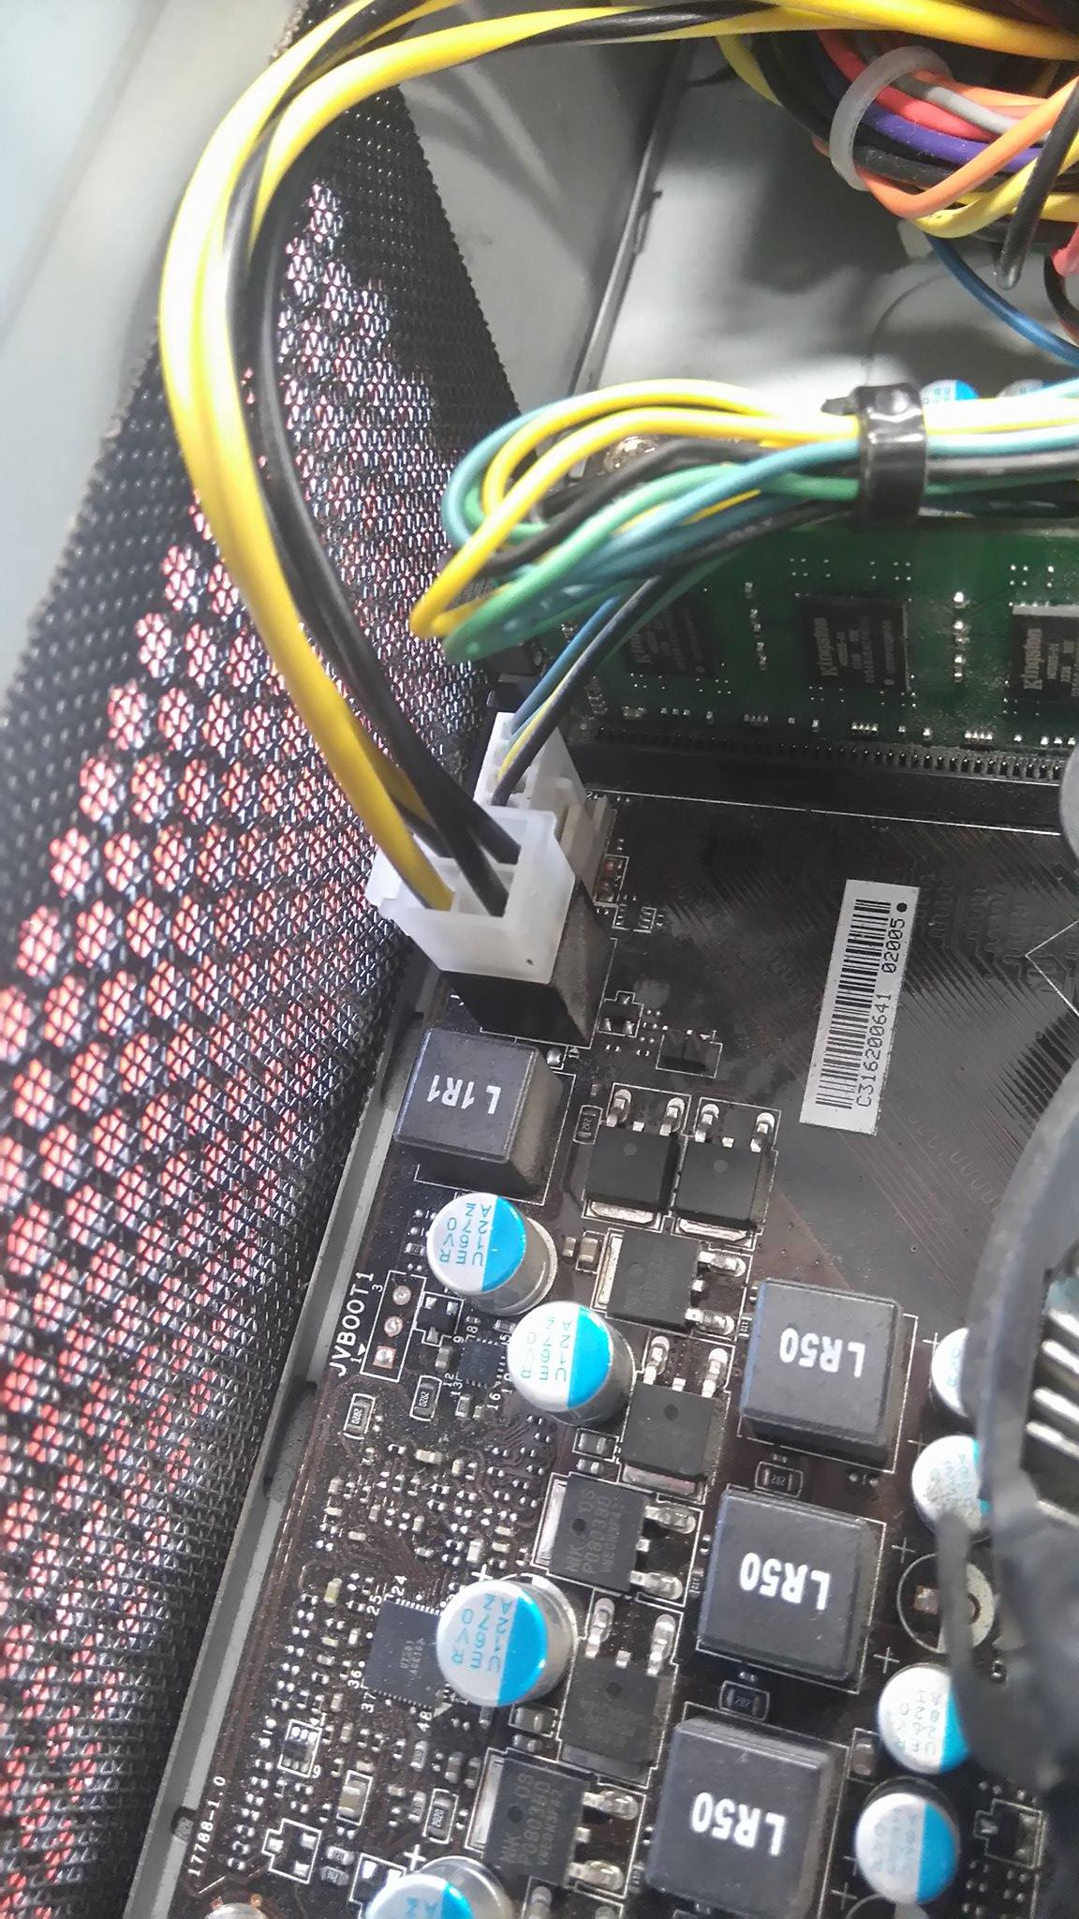

I then plugged in the fan header for the heat sink so that the fan would spin when needed.

## RAM

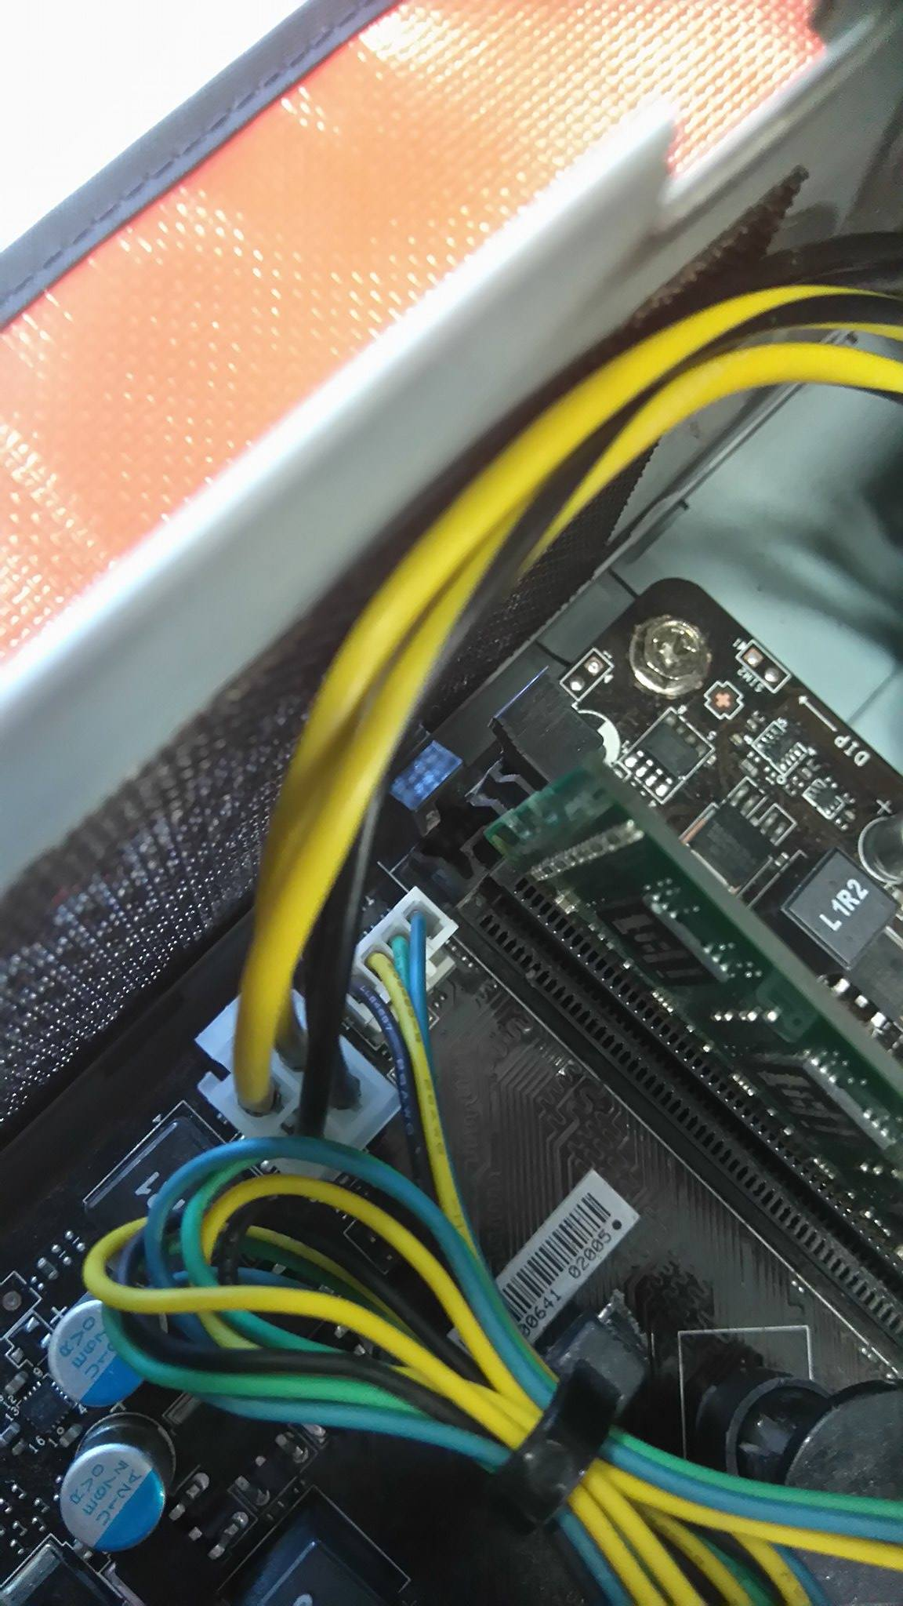

I noticed that the RAM was not installed correctly. Due to this I decided to again entirely remove it and then re-install it.

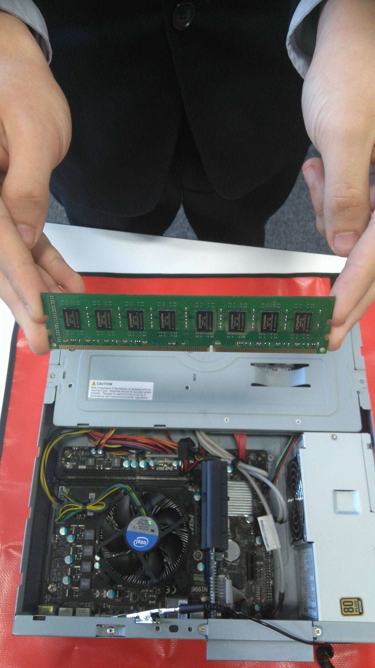

We removed it by pushing down the pins either side of the stick and lifting the RAM out. Above is an example of how you should hold the stick once removed. It avoids touching any connections, possibly damaging the stick.

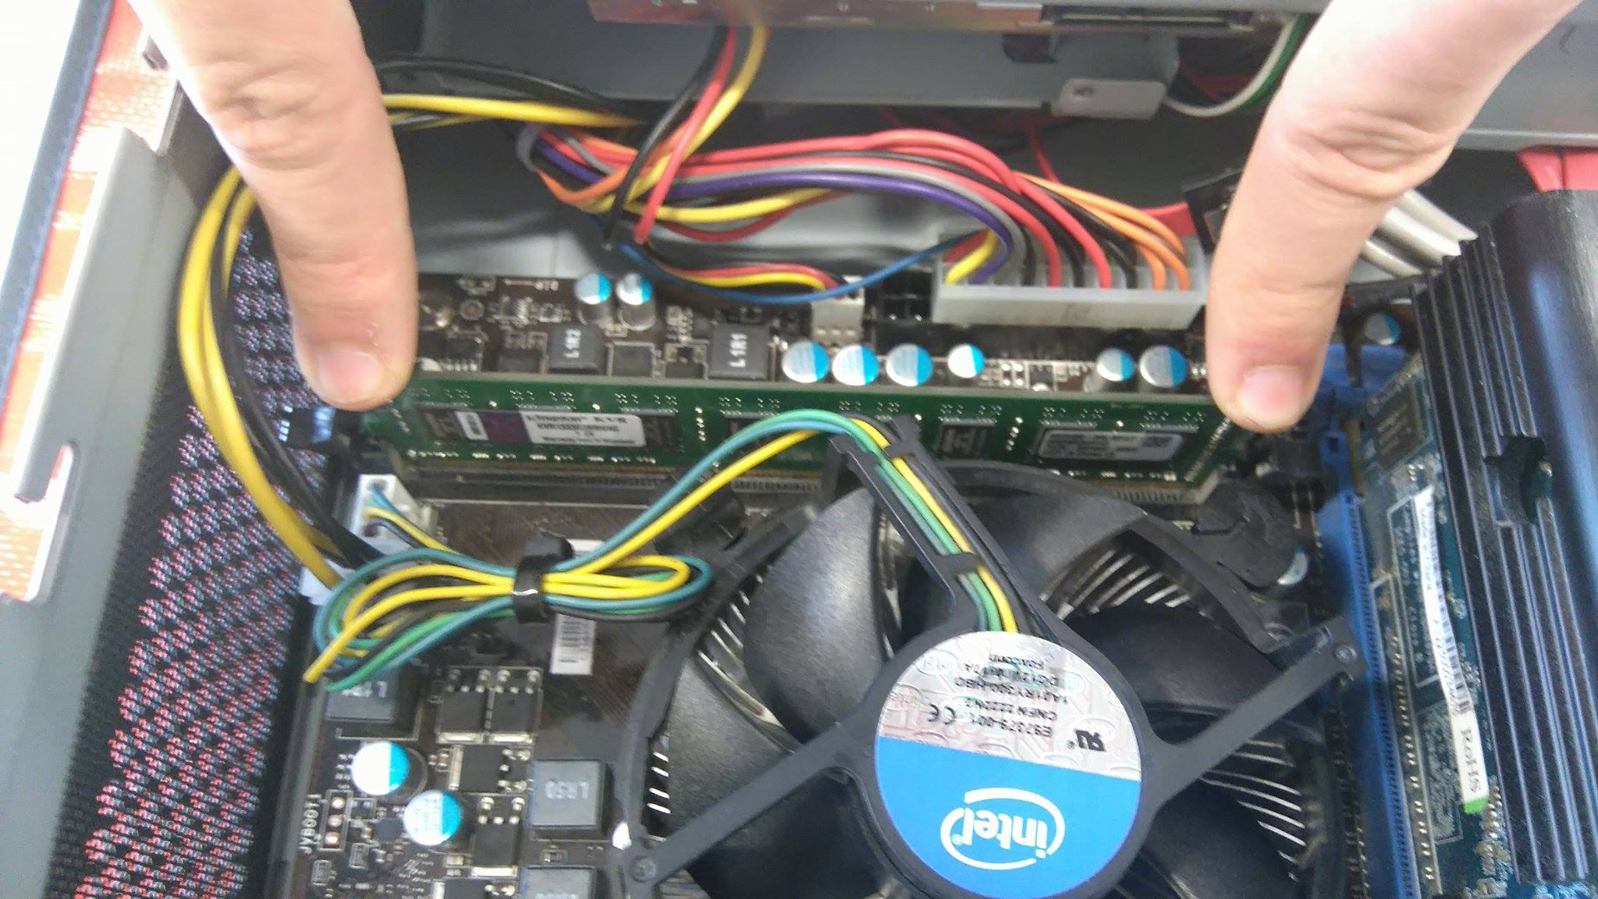

I then placed the stick in the socket and pushed evenly on both sides. It is important to line up the stick with the long side and short side of the socket. When you hear a click from both pins It is correctly installed.

## Software

I decided that one piece of softwar that the company would need is Microsoft Office. This would be used for general word processing, tables (in Excel) and more advanced things like databases (in access).

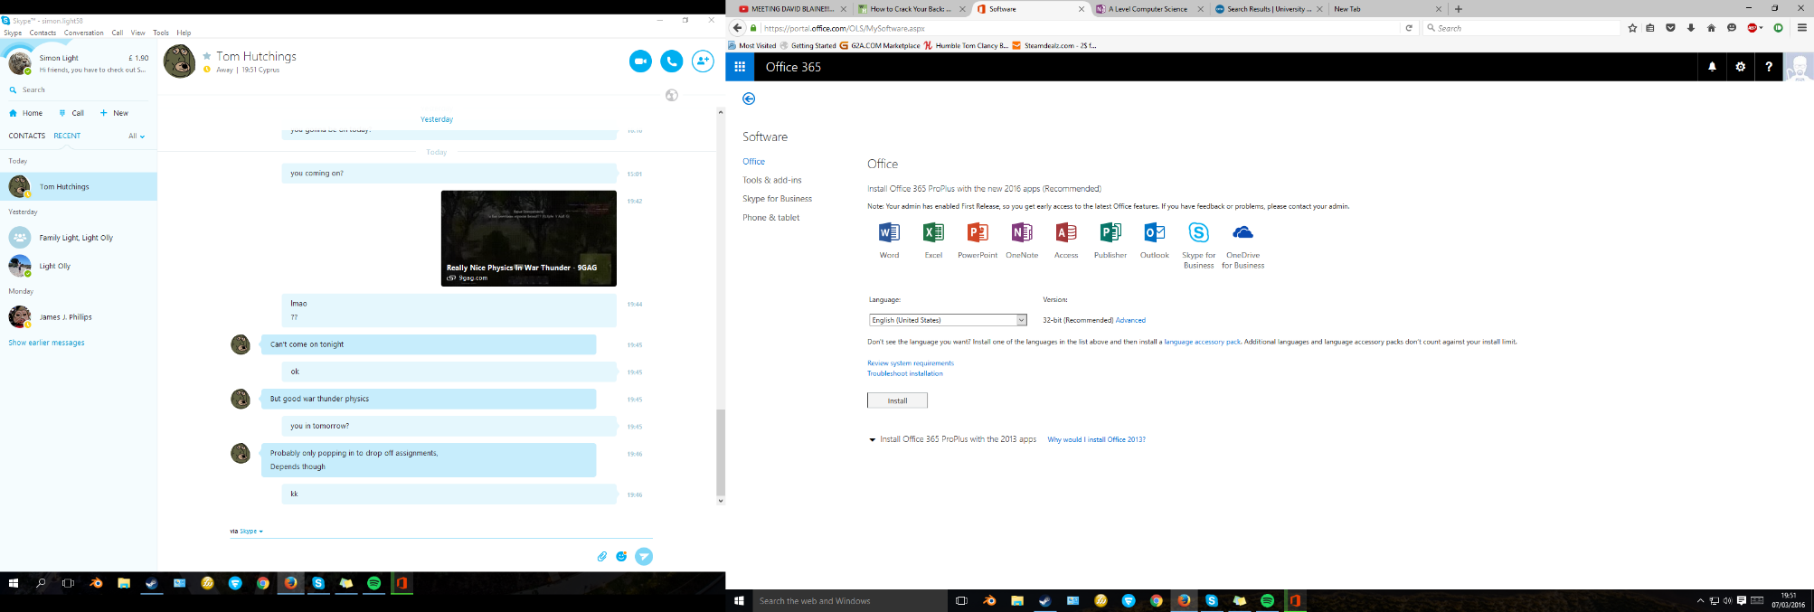

I next went on to the internet and found a place to download the latest version of Office which is 2016. I then selected my language to install in and pressed install.

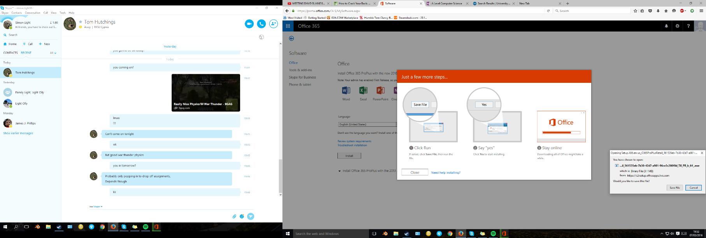

I was then prompted with a window asking me whether I wanted to save the file, I did. I then followed the instructions on screen to run the file. This consisted of pressing yes when asked.

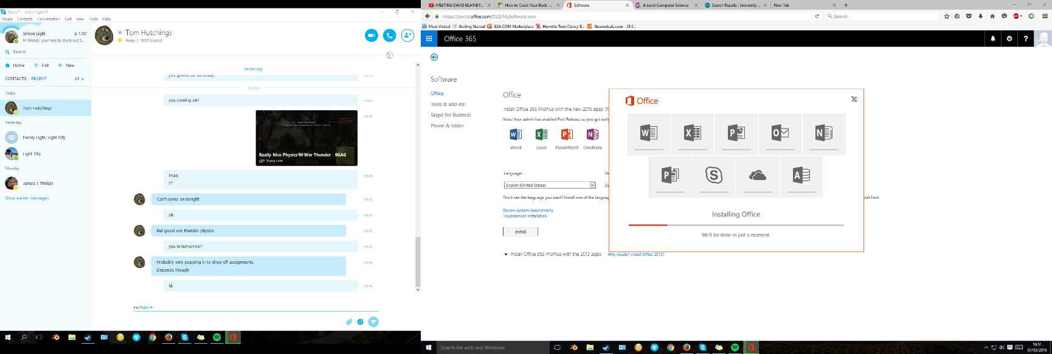

I was then given an Office installation screen that began to install the software in my default location. This means that it will be available through the start menu and the programs section in controll panel. The window showed me how far throught the installation it was aand what it was doing at each point.

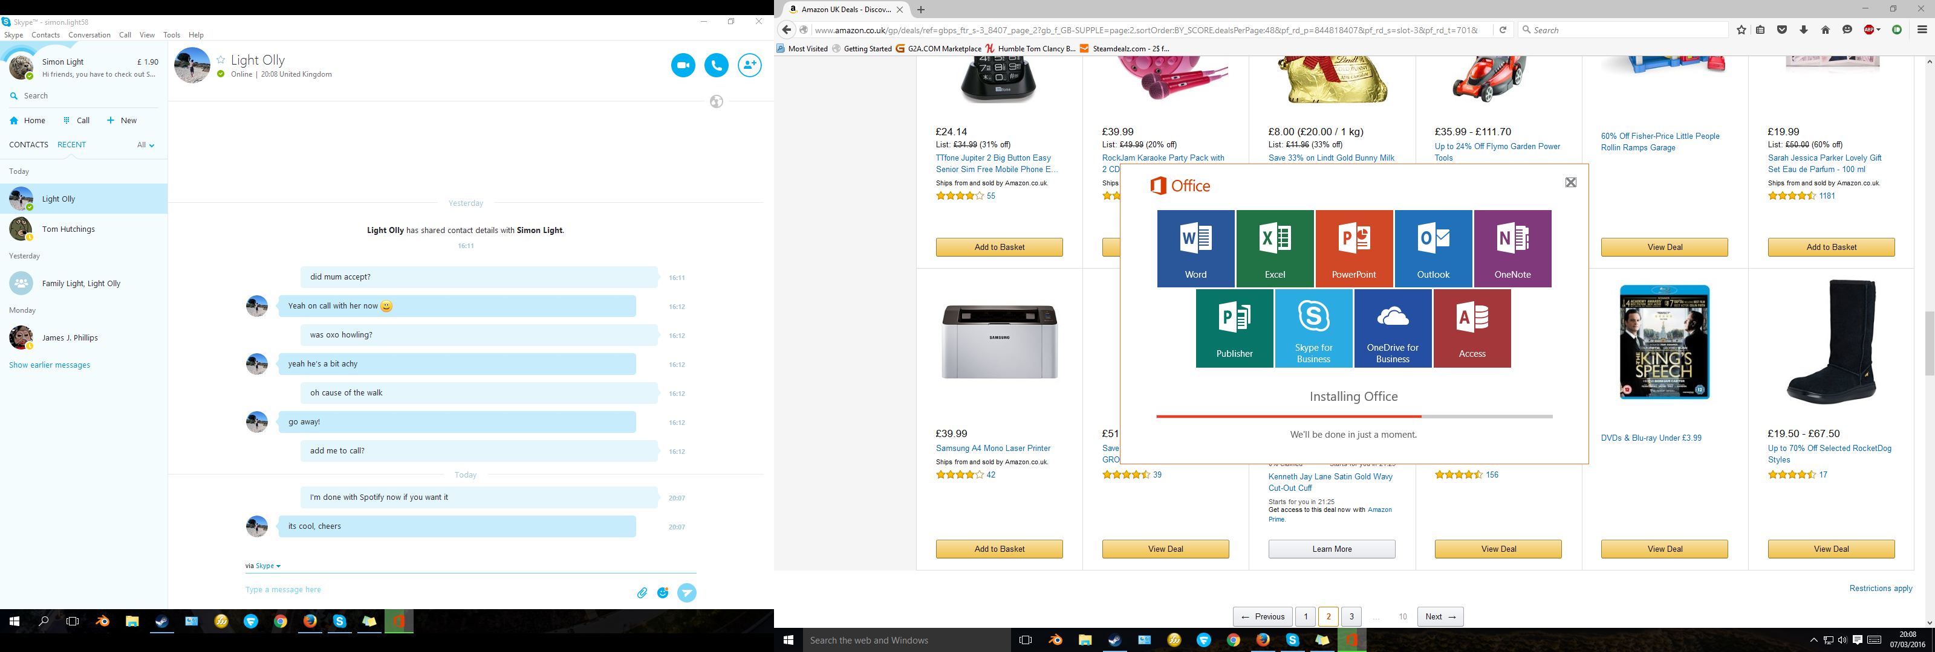

One by one after the programs had installed they became coloured rather that black and white. You could then click on these to run the program and confirm it was working ok. After all of the programs were installed it carried on doing some setting up but all of the applications could be used.

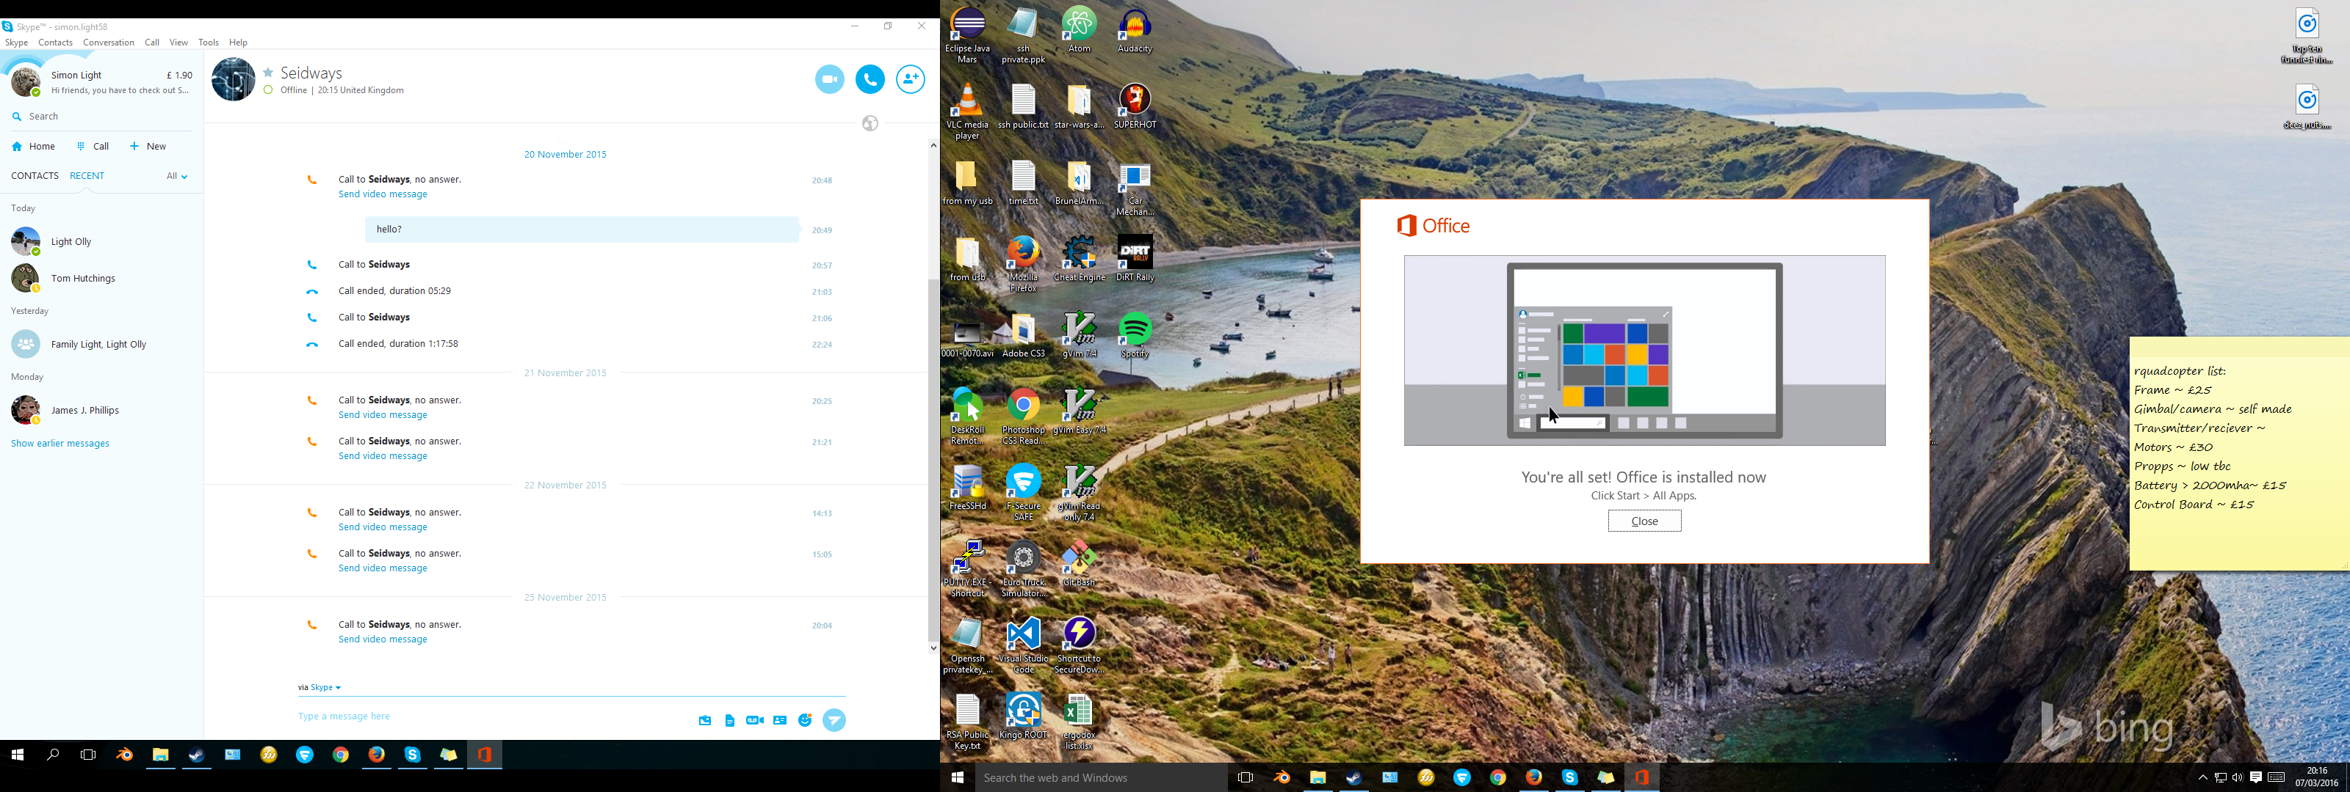

After the installation had completely finished I was shown this window. It explained that the applications that I installed could be found in the start menu.

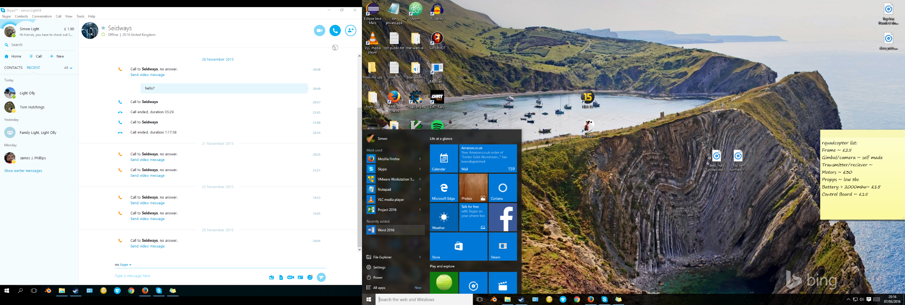

I then pressed clos on that window and proceeded to check. As you can see in the image above the applications were there and they all worked fine.

# P6 – Configure a computer to a user’s need

In this section I will configure a computer to a user’s needs.

## Power saving options

Here I am going to set up the computer to never turn off the display when it is charging. This will be good for running slideshows to customers of the TelXGroup.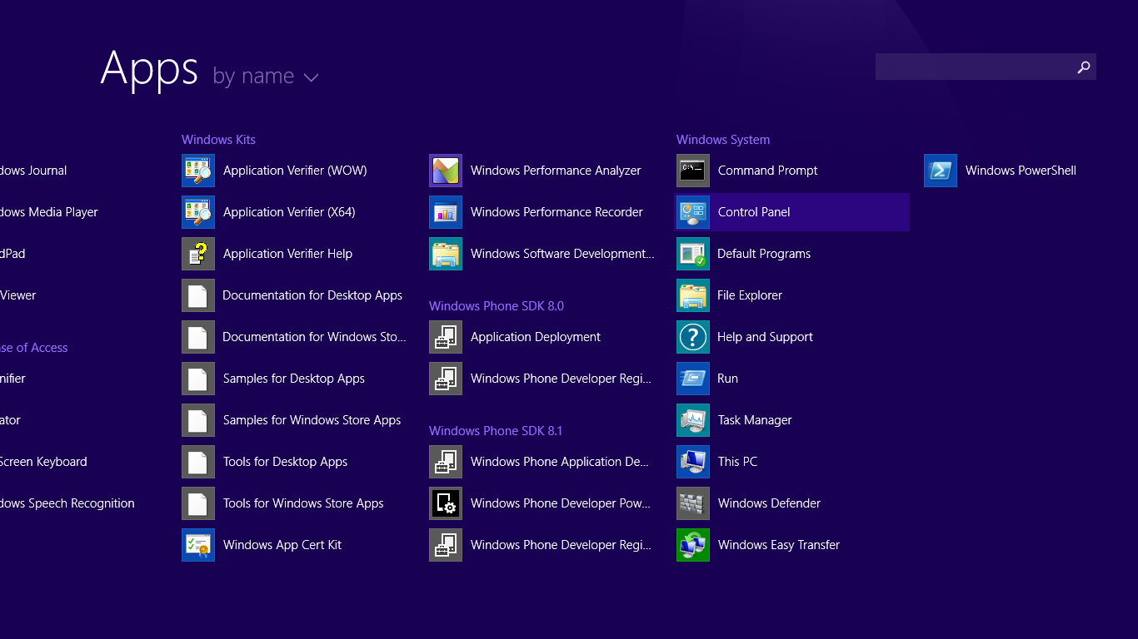

I firstly opened control panel by going through Start, down arrow then Control Panel.

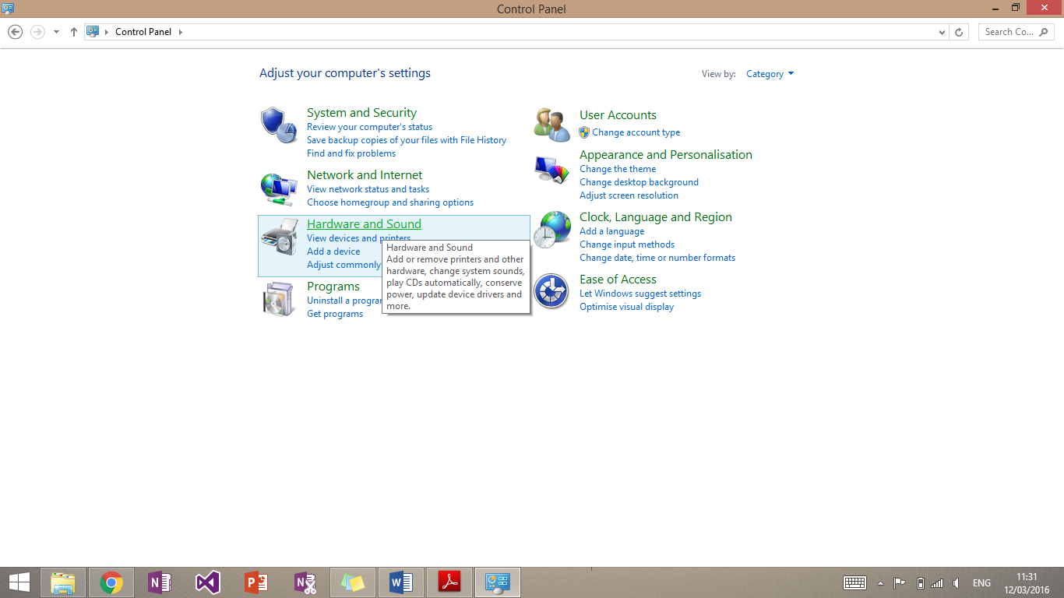

I was then presented with the main control panel page. I then clicked on ‘Hardware and Sound’.

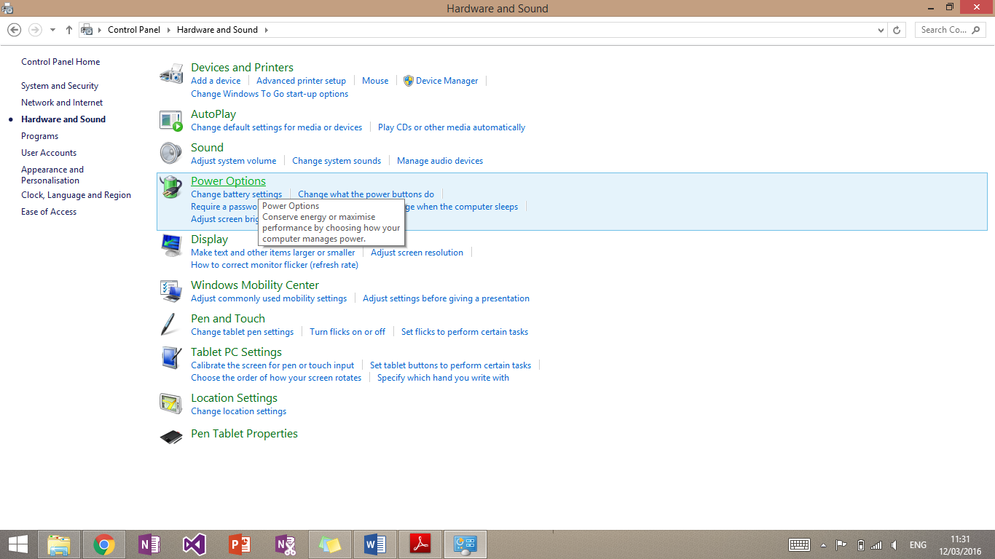

This then brought me to the Hardware and Sound page. I then clicked power options.

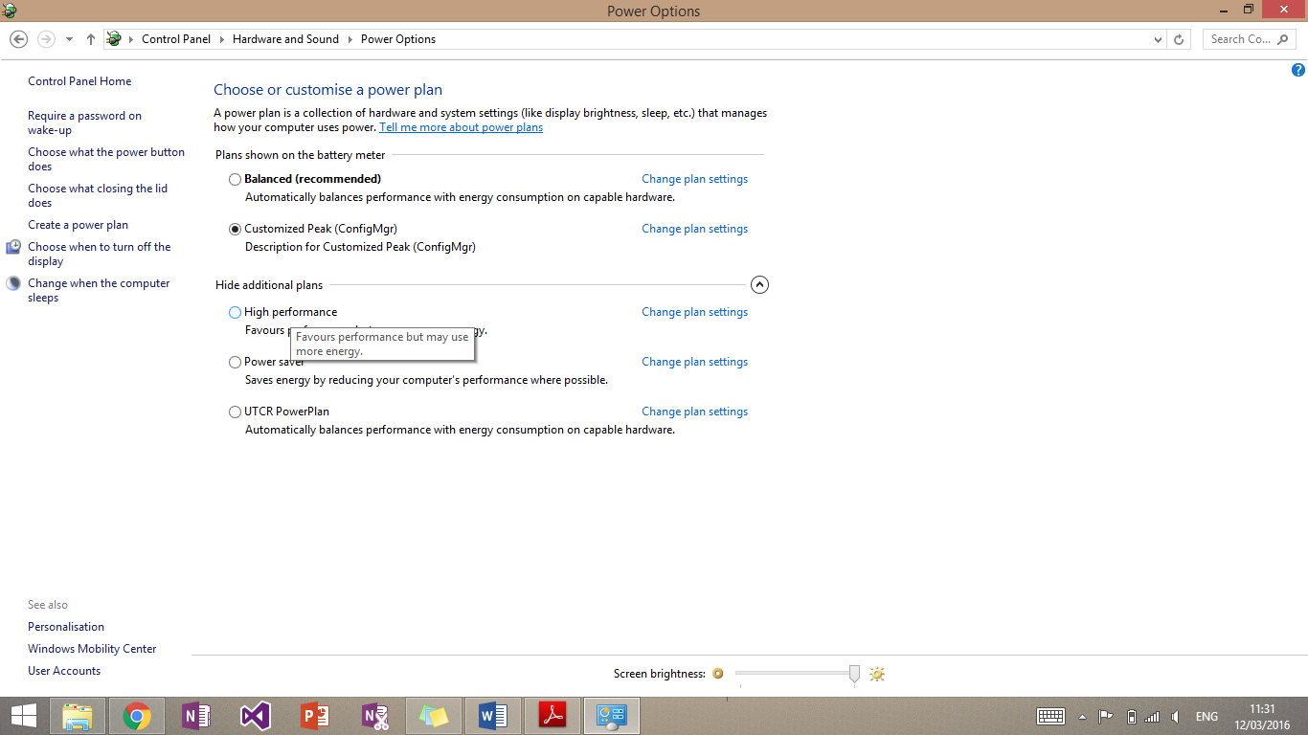

From here I could set up everything to do with power management. The section I wanted was called “Choose when to turn off the display”. This was located on the far left of the page.

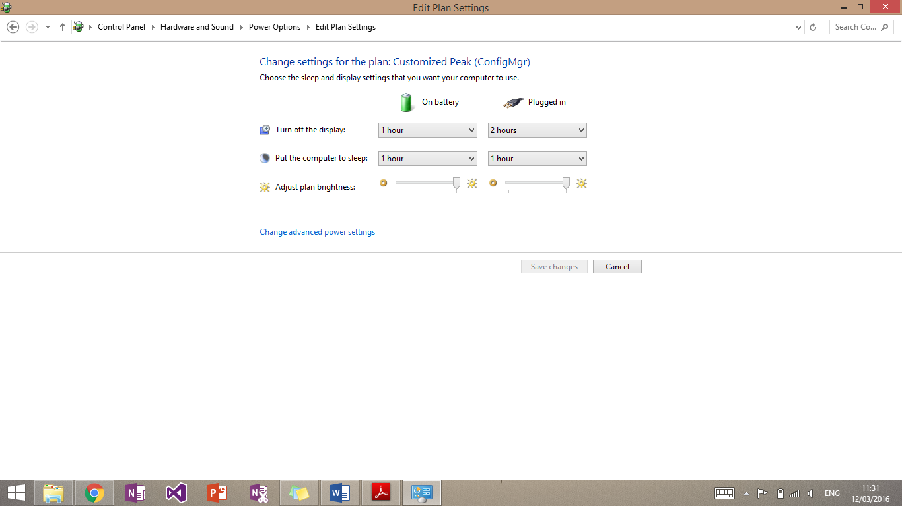

This then brought me to a page called “Edit Plan Settings”. From here I could specify what happens when the computer is plugged in or on battery.

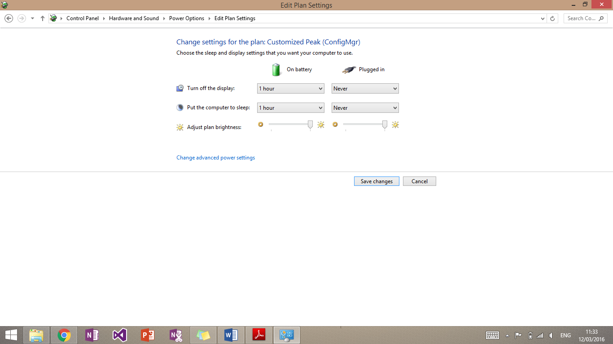

I set up the computer as shown above by using the drop down boxes. This set up would mean the computer would never turn off the display or go to sleep when it is charging, as depicted above. I then confirmed all, of this by pressing the ‘Save changes’ button.

## Screen resolution

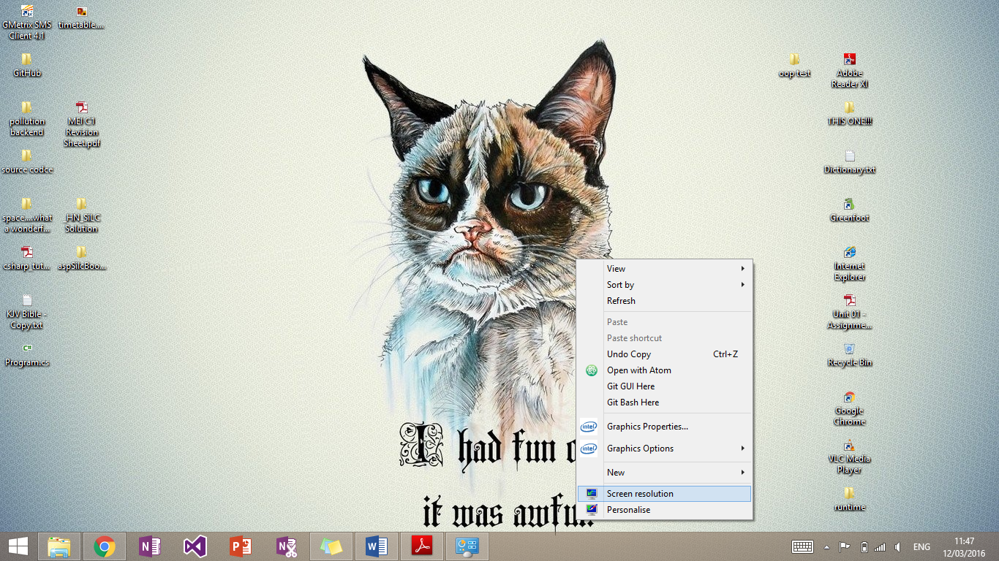I wanted to setup the resolution of the computer to be the native resolution of the display. This can be identified by the “**(Recommended)**” in the screen resolution page.

The screen resolution page can be found by going to the desktop and right clicking the background. Then select the ‘Screen resolution’ icon.

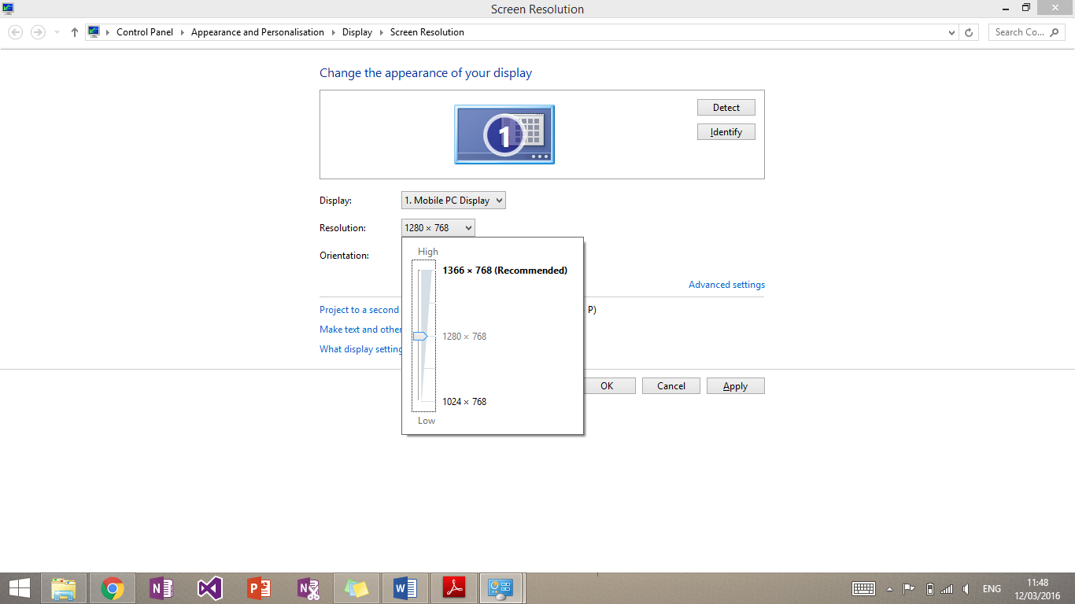

I then selected the resolution drop down box. This is how found it. Obviously it was no at the native resolution as detailed above.

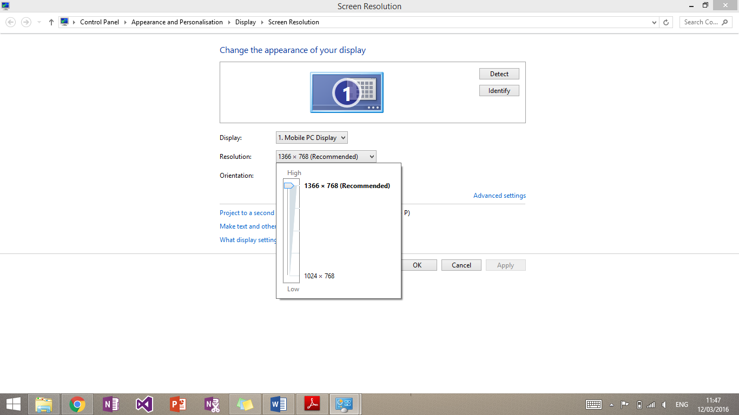

I then selected the native resolution and pressed ok to confirm it.

## Desktop theme

The user may want to change the background to the company logo or something personal to them. I will be showing the latter.

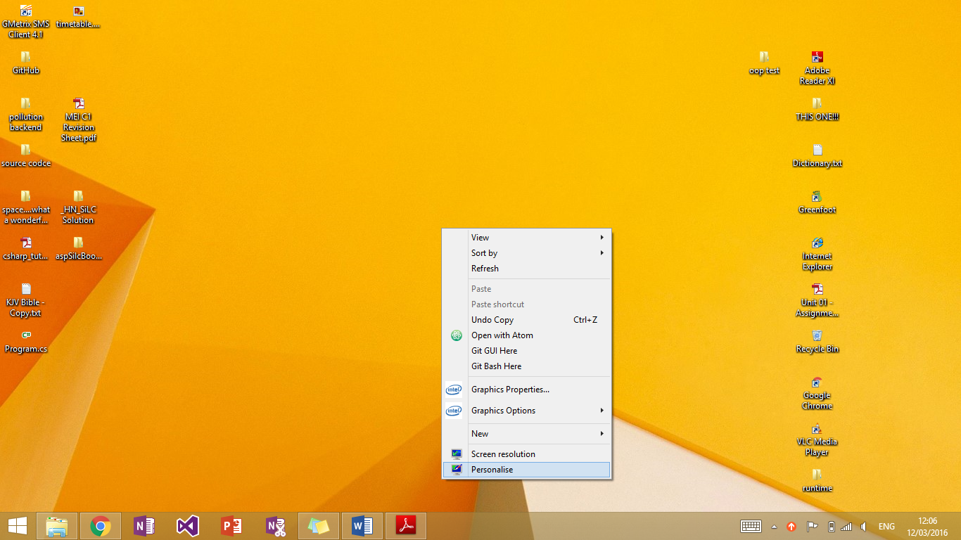

To get to the right page I right clicked the desktop and selected the ‘Personalise’ icon. 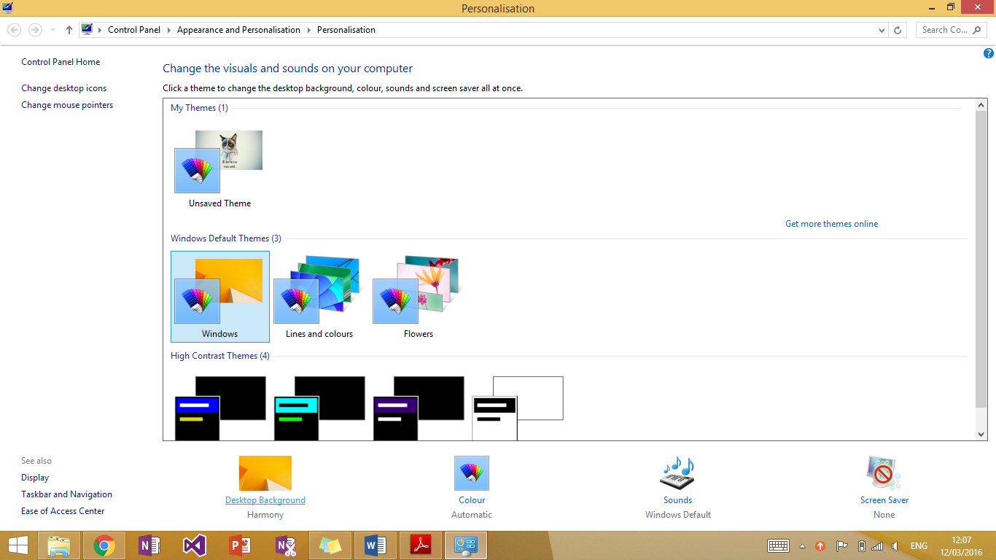 That then brought me to this page where I could choose premade themes. I selected the ‘Desktop Background’ link shown at the bottom of the page.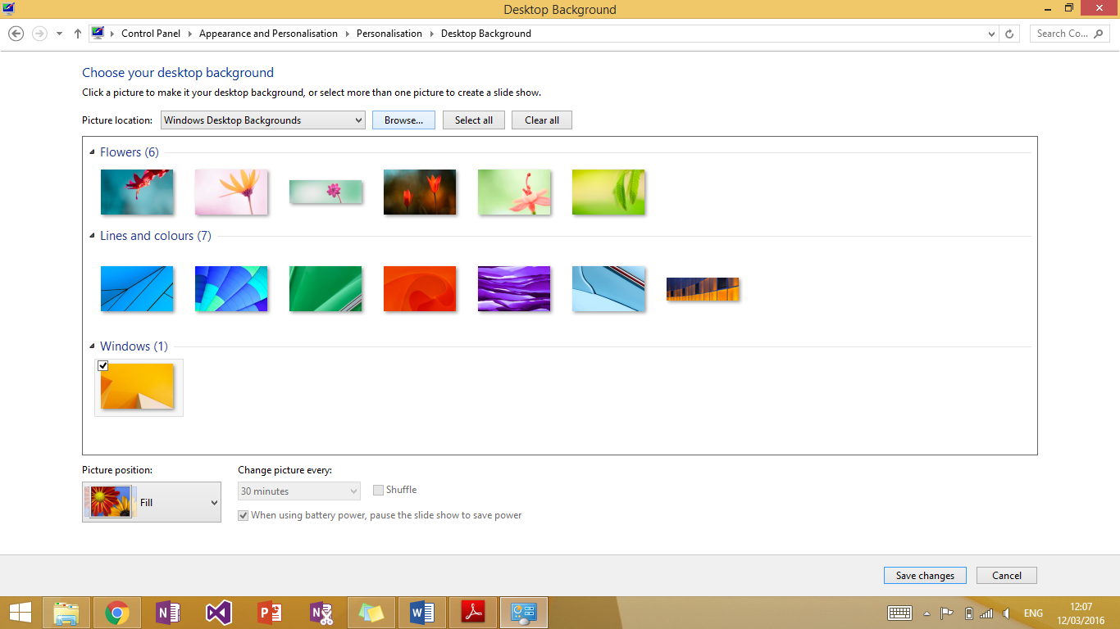

I then selected browse at the top of the page to navigate to the chosen file. 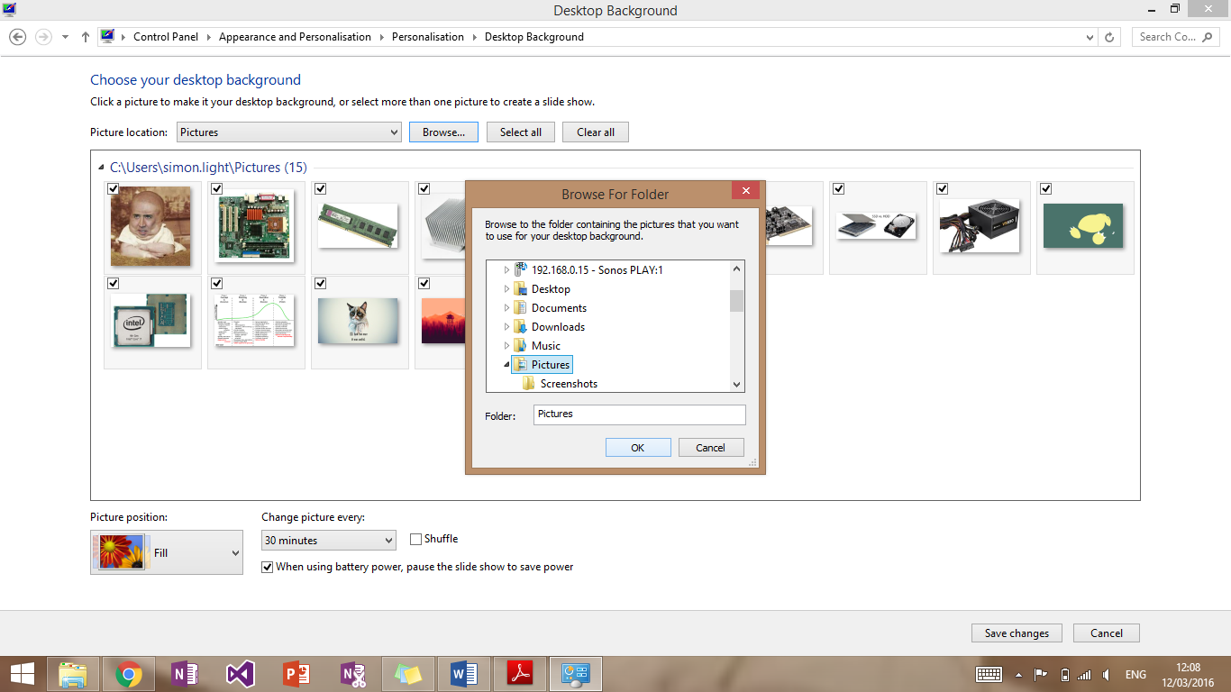

That then displayed this window. Once I had navigated to the preferred image (mine was stored in Pictures) I pressed ‘OK’.

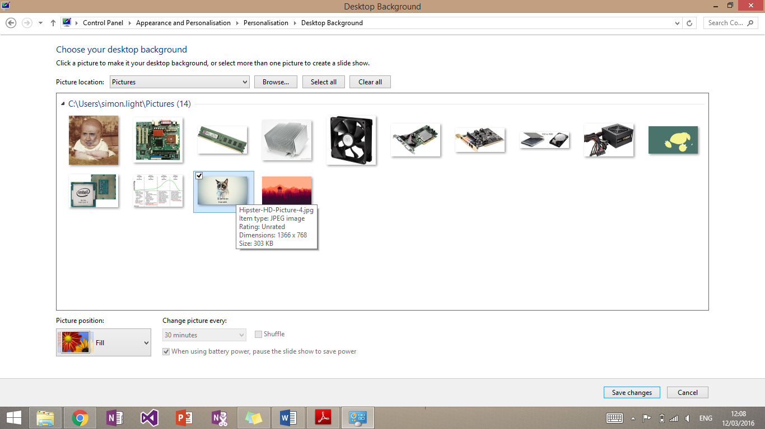

This then showed all images in that folder for me to choose from. Once I had done this I confirmed my decision with the ‘Save Changes’ button.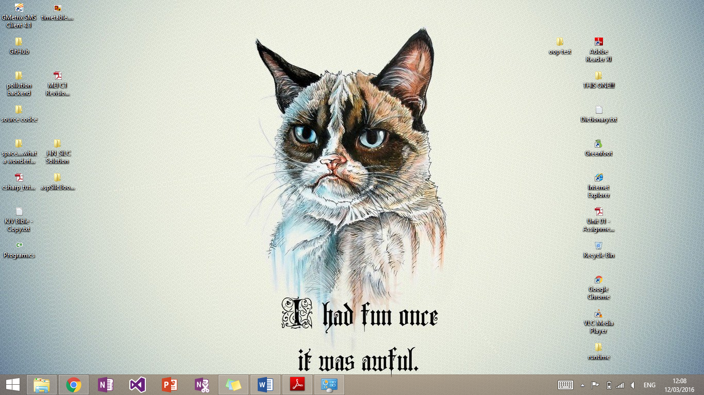

This then made my chosen image the background of the desktop as shown above.

## Font size

A user may want to make the text on their computer larger if they are visually impaired.

To start I opened control panel and typed in the search bar at the top right “font”.

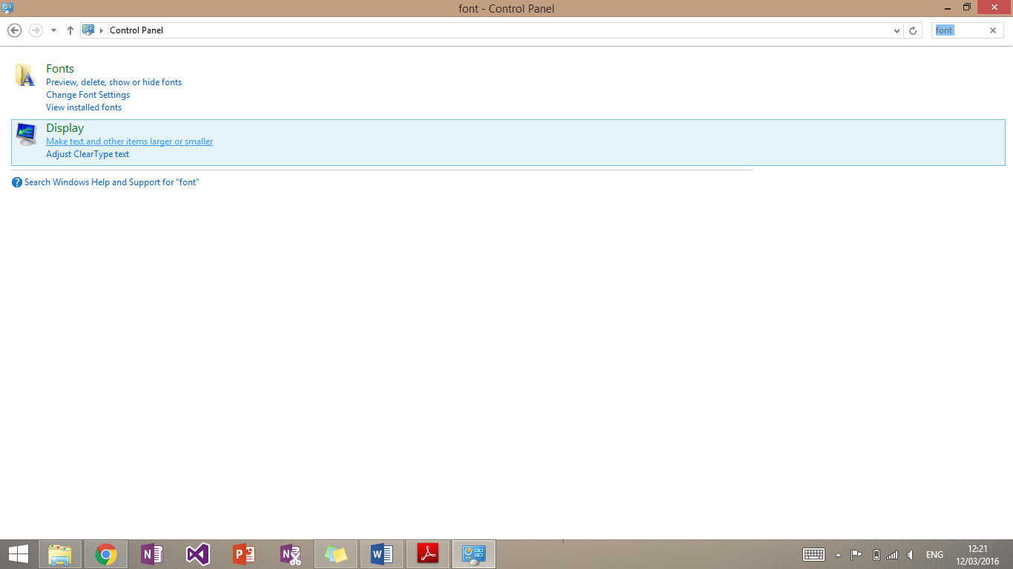

This will bring up this window. I then clicked “Make text and other items larger or smaller” under the “display” tab. 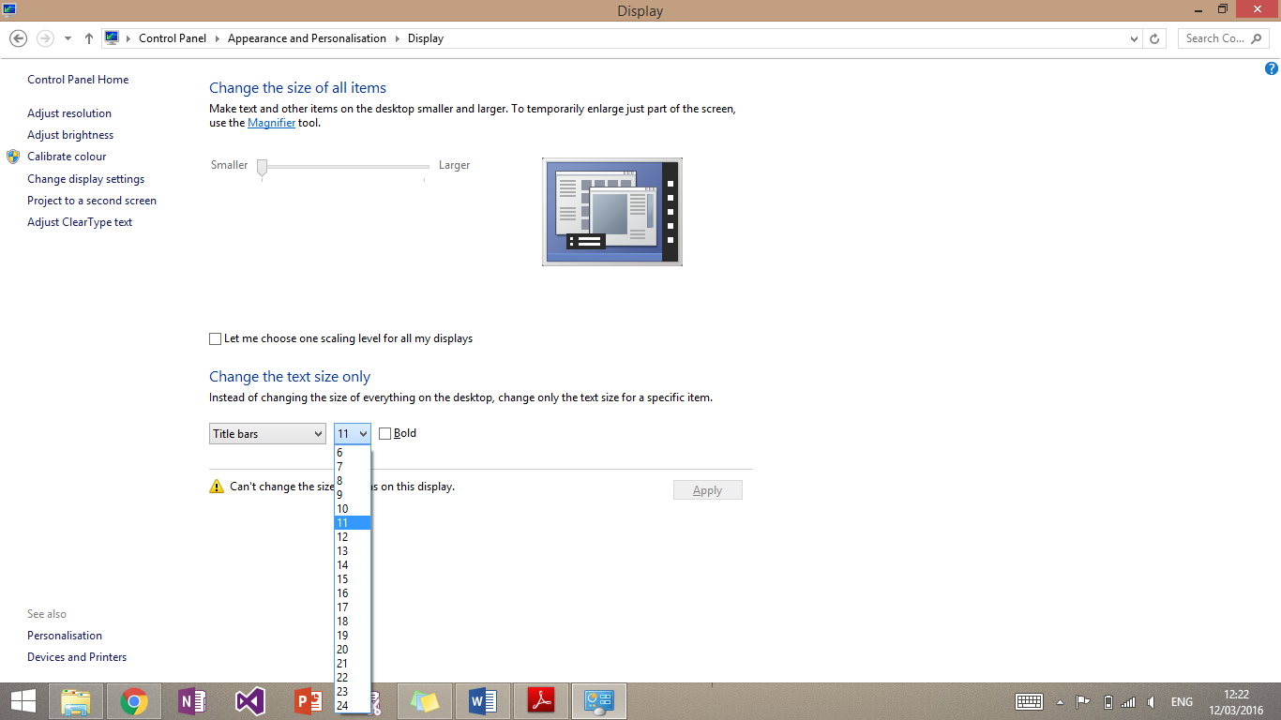

It will bring up this page. Then press the drop down box to change the font size. The default size is 11.

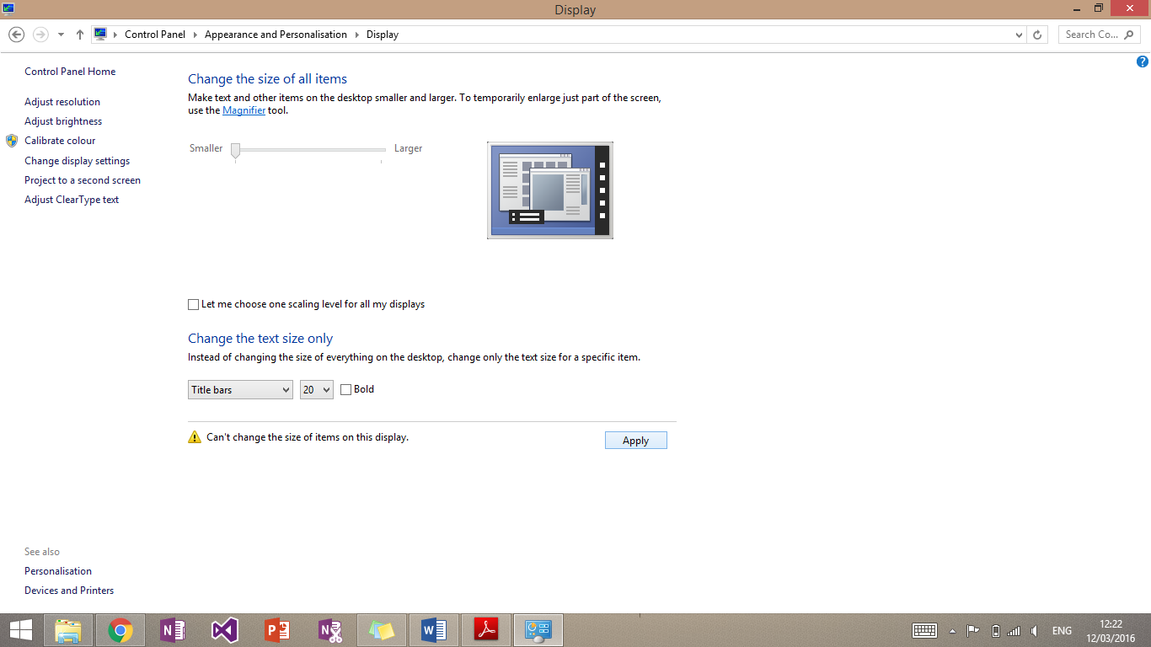

You can then change the size as required and then press ‘Apply’ to confirm this.

## Default language

A user’s native language may not be English. This means that they may need to change the language on the computer for ease of use.

I started off by opening control panel and searching for language.

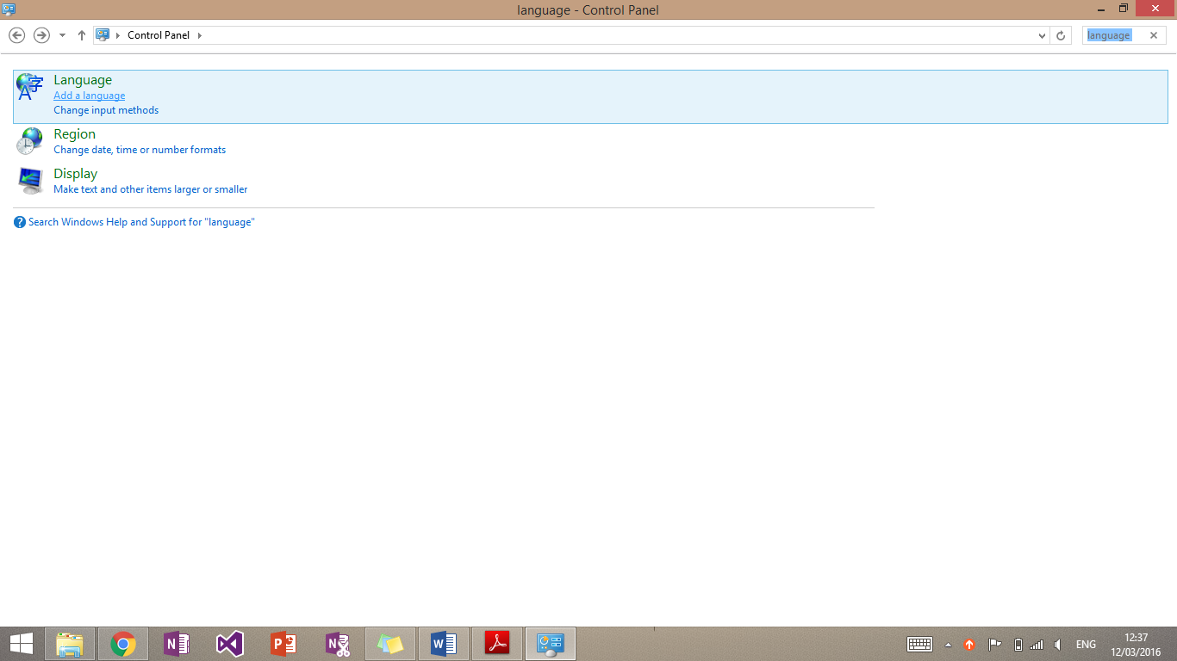

I then clicked “Add a language” under the ‘Langauge’ tab.

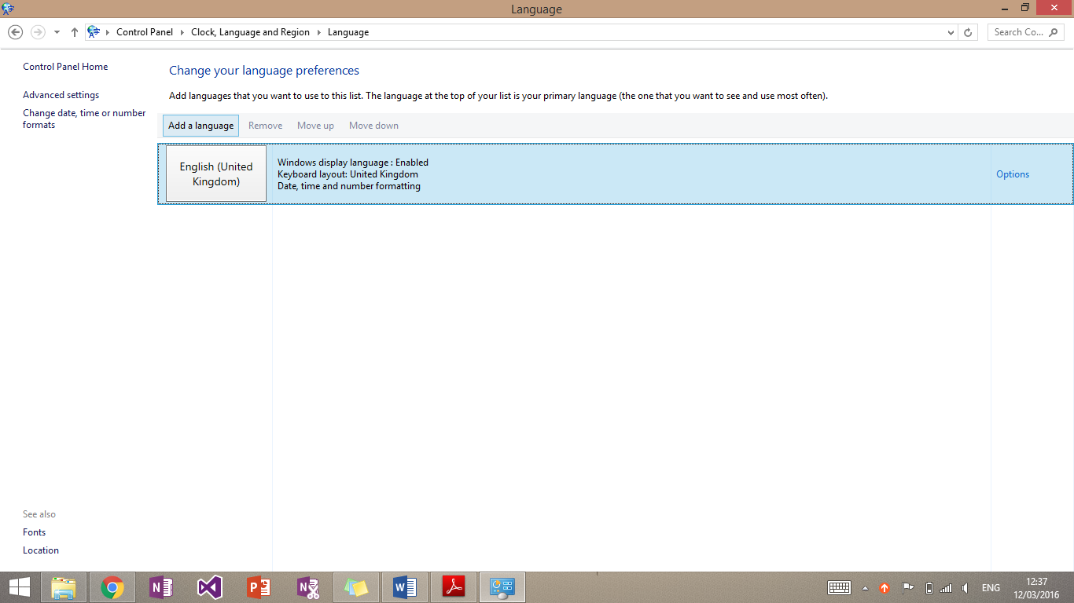

I then selected add a language.

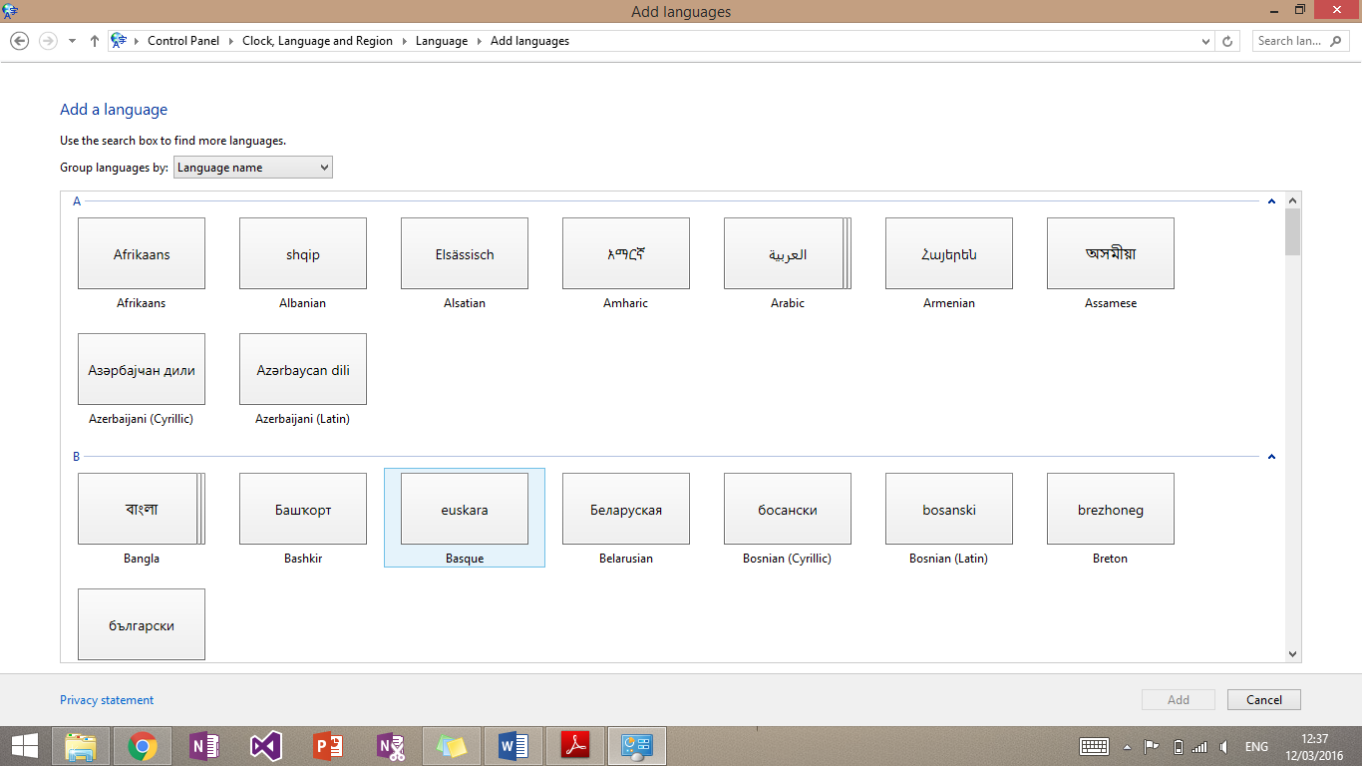

I would then select the language required and press add. It will then install the language pack and may require the computer to restart.



Once this is done return to this point, click the language required and then press “Move up” as shown above. I have not done this on this computer as another language is not required.

# P7 – Test a configured computer

Once I had configured the computer I had to test whether it was configured correctly. The test should check whether the system is working correctly, all hardware is correct and present and all applications are working correctly.

Below is a test plan of how I will make sure of this.

|  |  |  |  |
| --- | --- | --- | --- |
| Testing | Condition/Action | Expected Outcome | Actual Outcome |
| Time and Date | Check time and date compared to actual time and date | Both are the same | Both are the same |
| Opening Software | Open OneNote | OneNote Launches | OneNote Launches |
| Start Button | Log out | Logs out | Logs out |

Below is evidence of these tests:

## Time and date

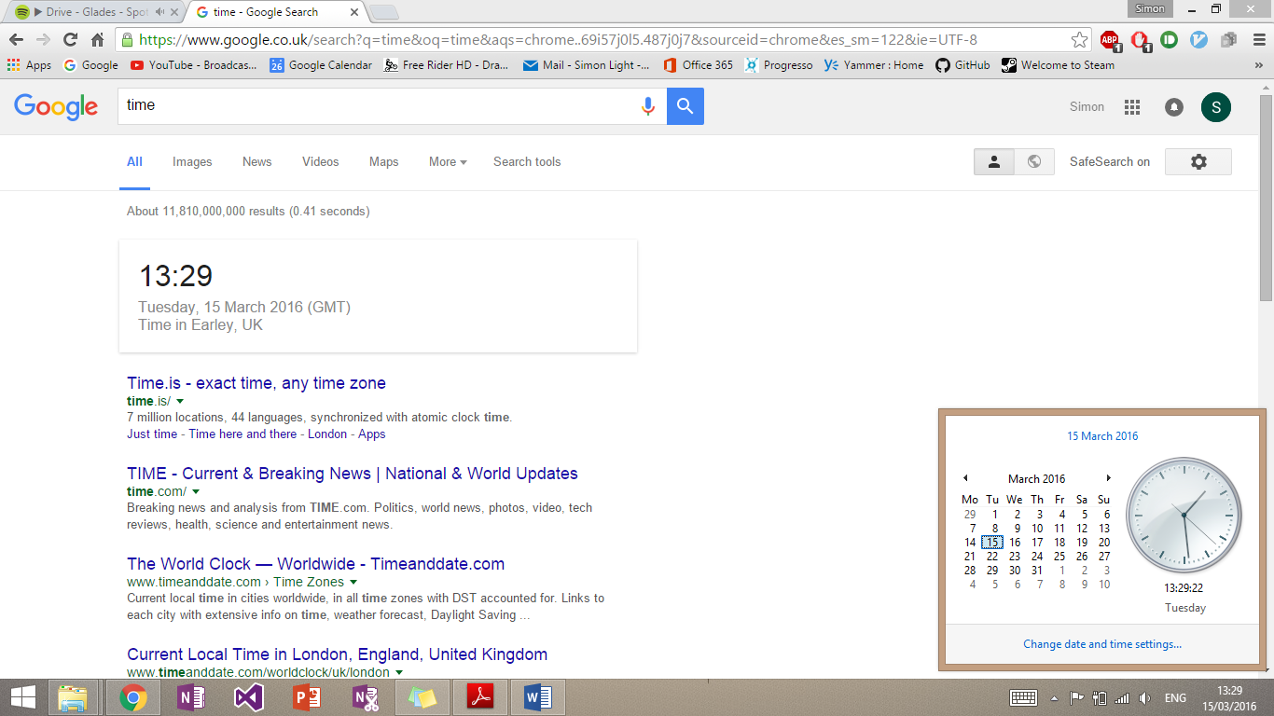

As you can see above I compared the time on the computer with the time displayed on Google. This is a secondary reliable resource to check against. The times were the same.

## Opening software

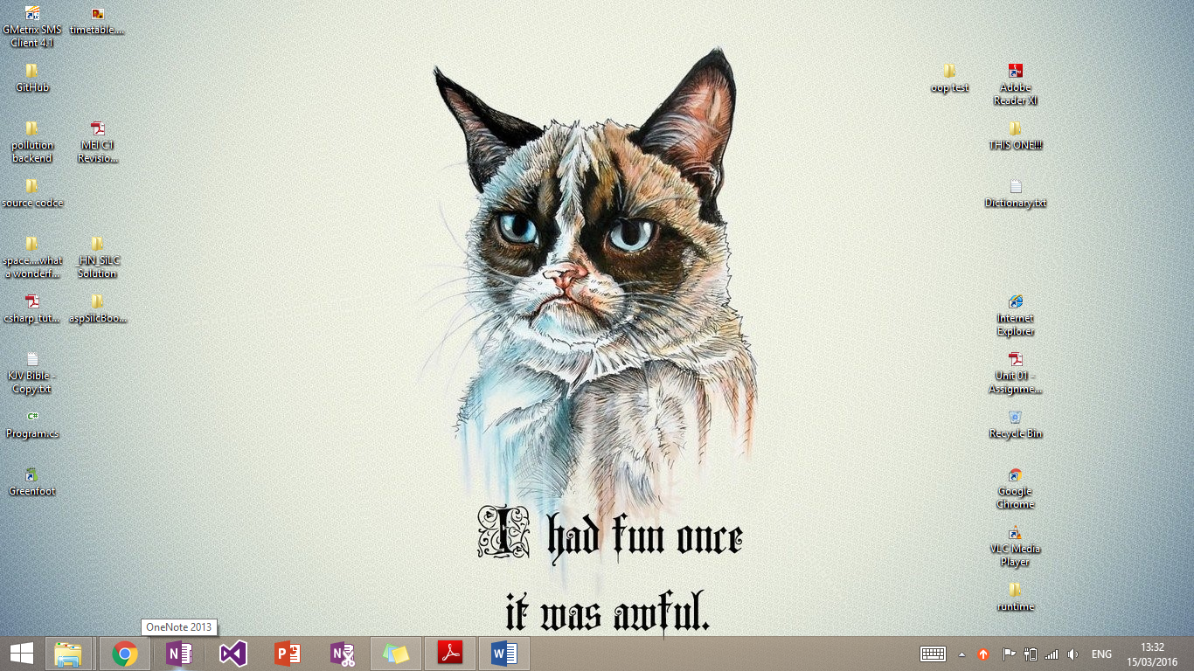

I clicked on the OneNote on the task bar.

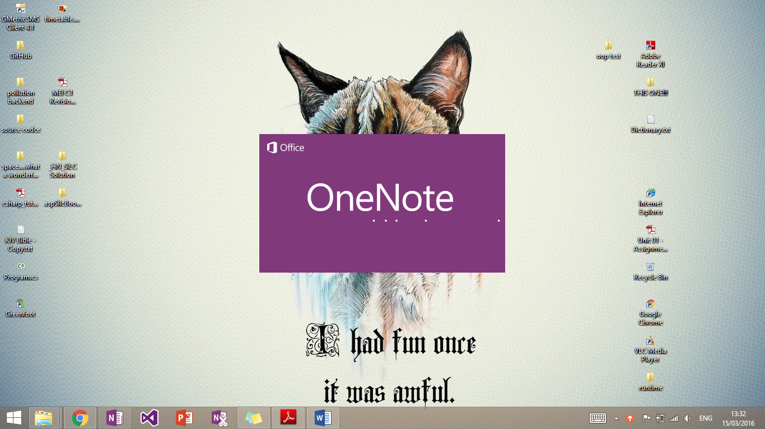

It then started to open OneNote.

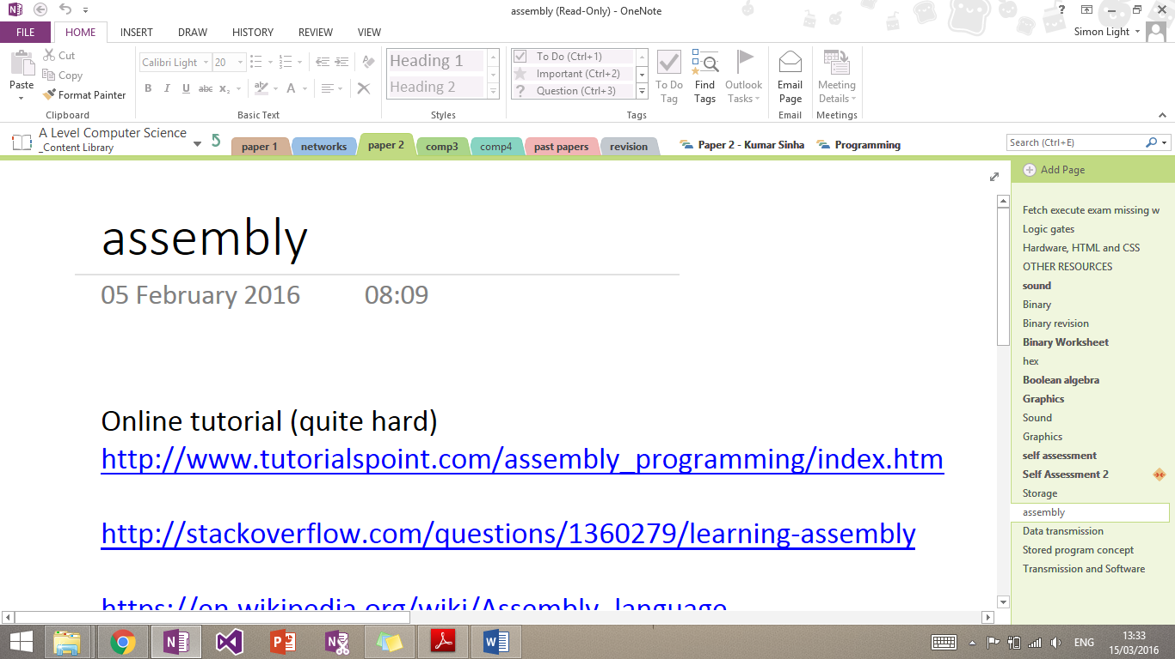

It opened OneNote successfully and passed the test.

## Start Button

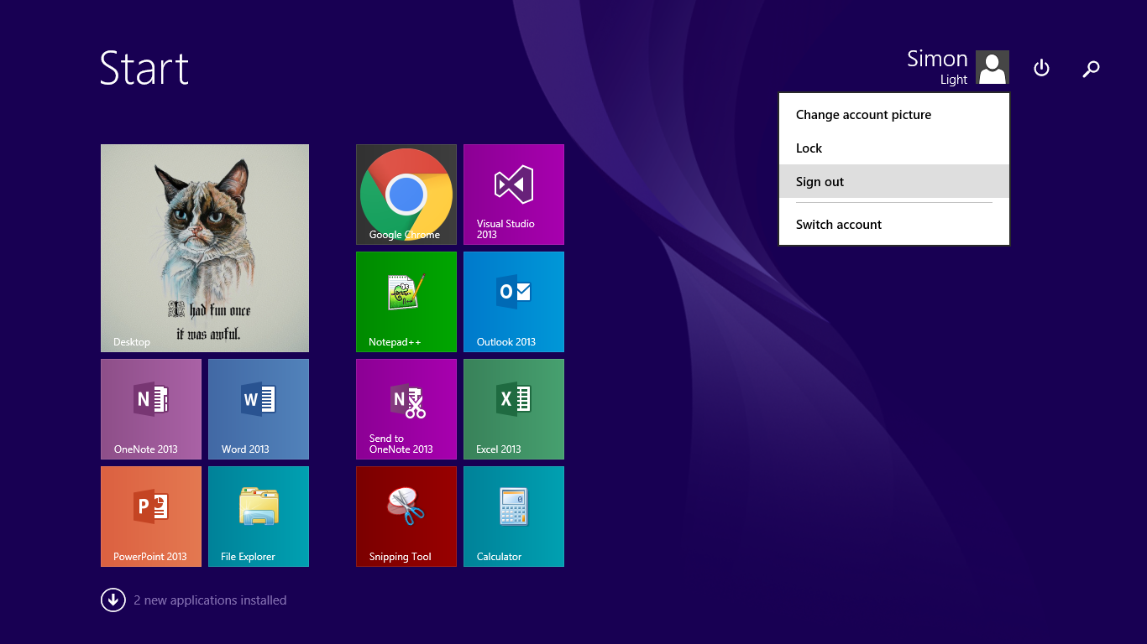

I pressed the sign out button and the computer successfully signed out. I could not give evidence but the test was passed.

# P8 – Routine maintenance

## Restocking printer

### Paper

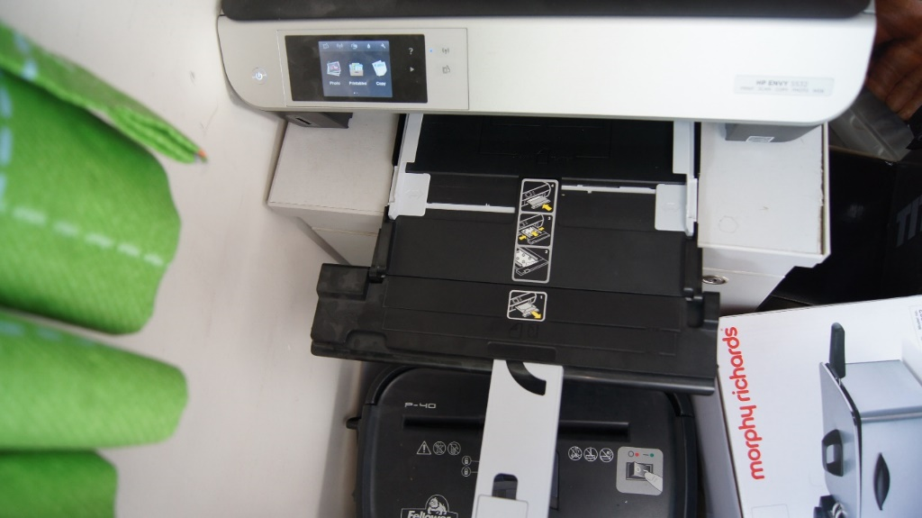This is the printer without any paper in it.

I firstly pulled out the paper tray.

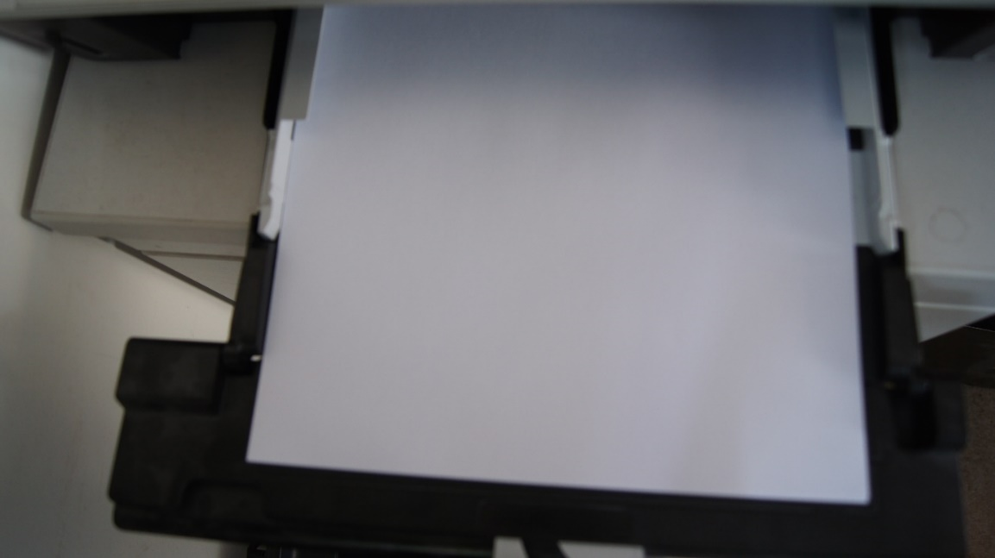I then loaded the paper into the tray.

And pushed the allignment pins until they were touching the paper

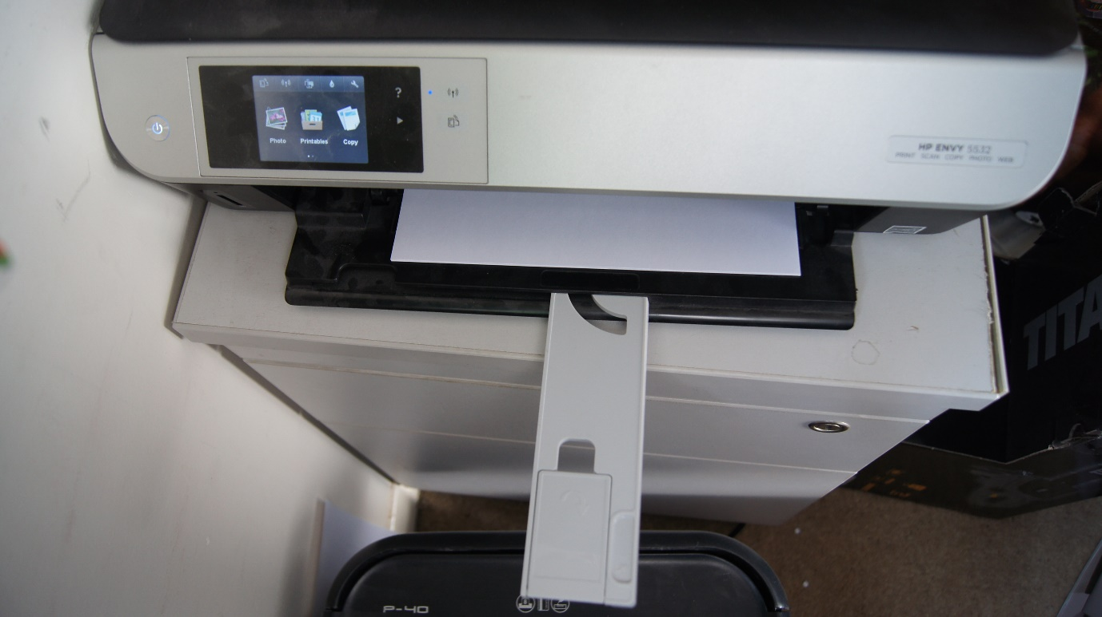

I then slid the tray back in.

### Ink

I started off by lifting the lid and locating the ink trays (far right hand side).

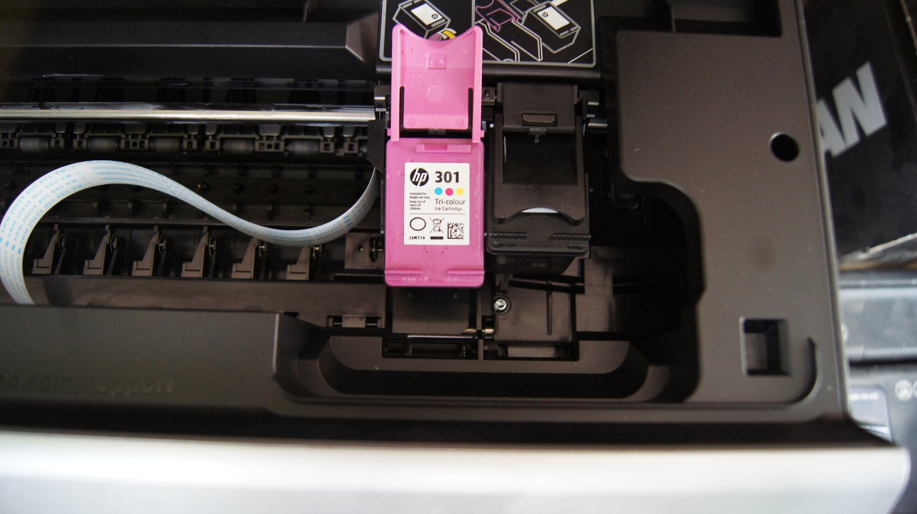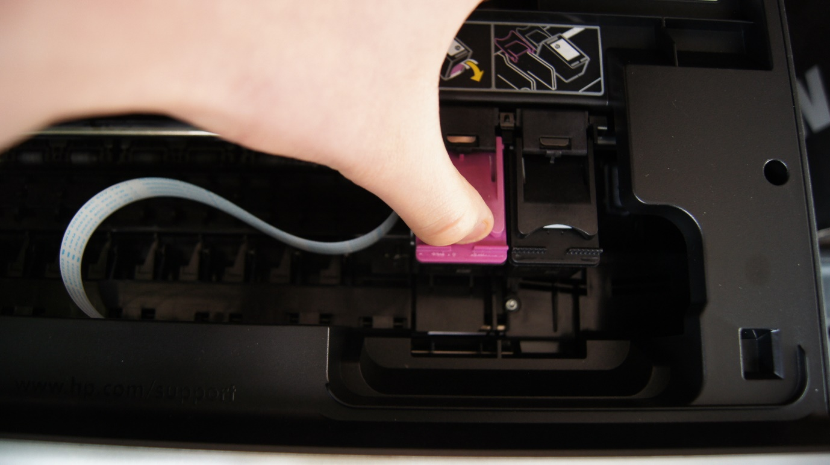I then lifted the release catch

And removed the cartridge

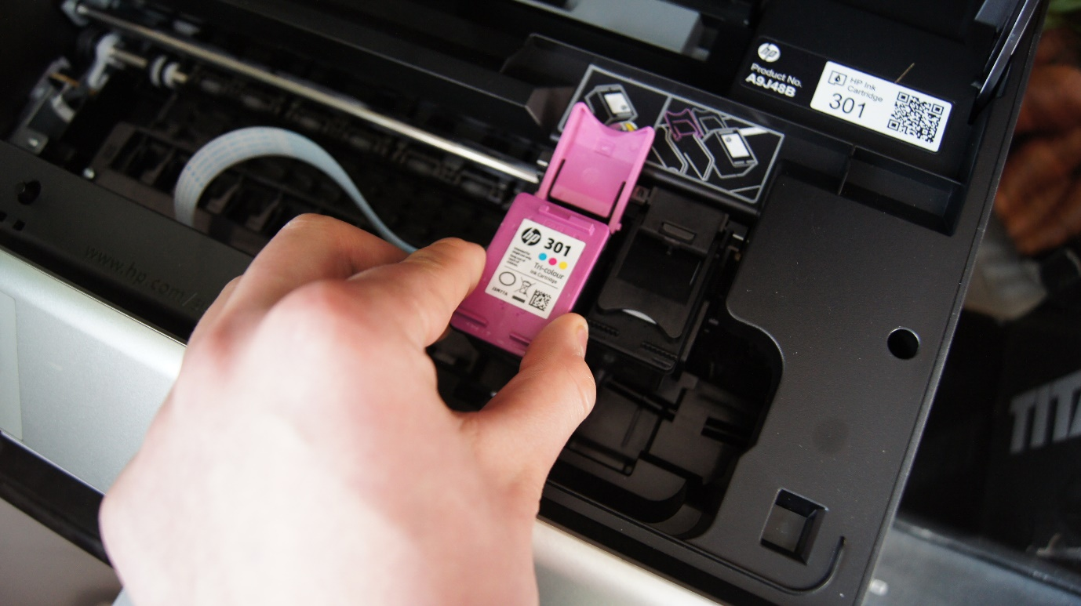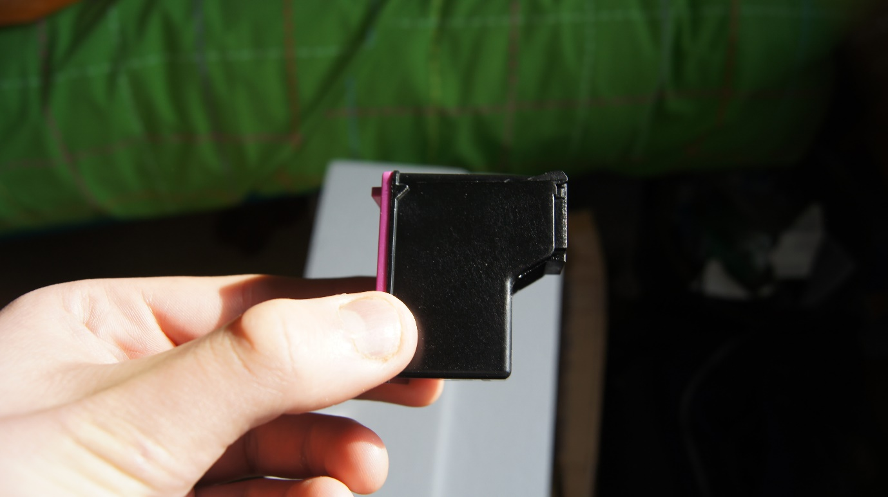I then found a replacement cartridge and checked it for compatibility.

I then placed the cartridge in the slot

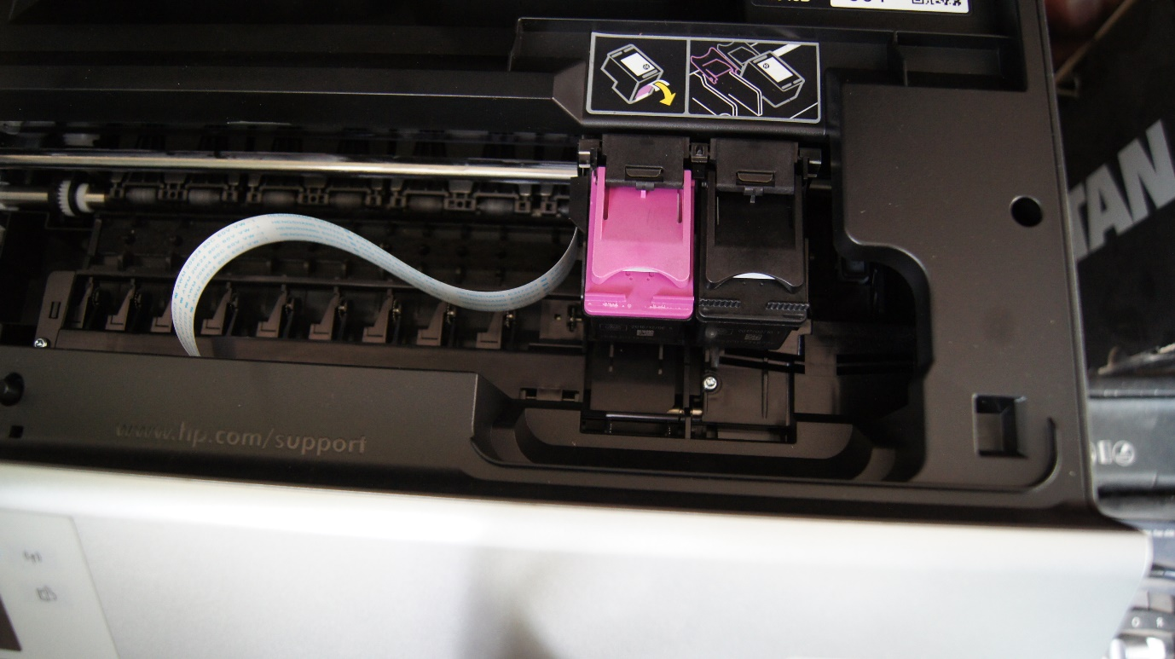

And closed the arm and then the lid

## Defragging disk

Disks need to be defragged to reduce the access time to files. This time is inreased when more files are added to the disk.

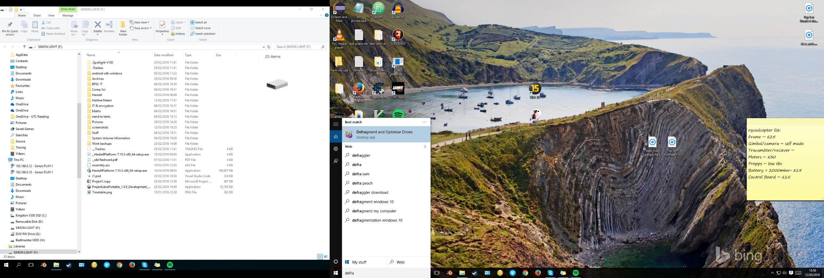

The first thing I did was search for defrag in the search bar. This then brought up “Optimise Drives”.

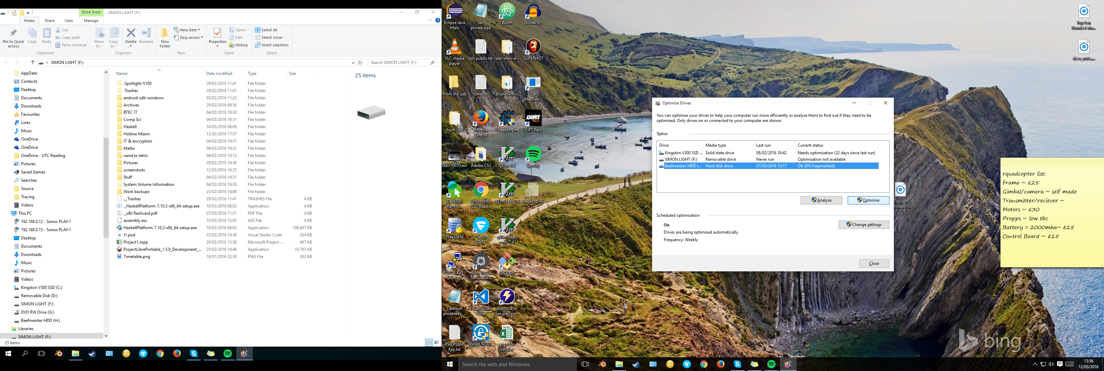

Once there I selected the drive to be defragged and clicked optimised.

It will then go through the steps to defrag the drive while you carry on using the computer.

# M3 – Evaluate performance of a computer

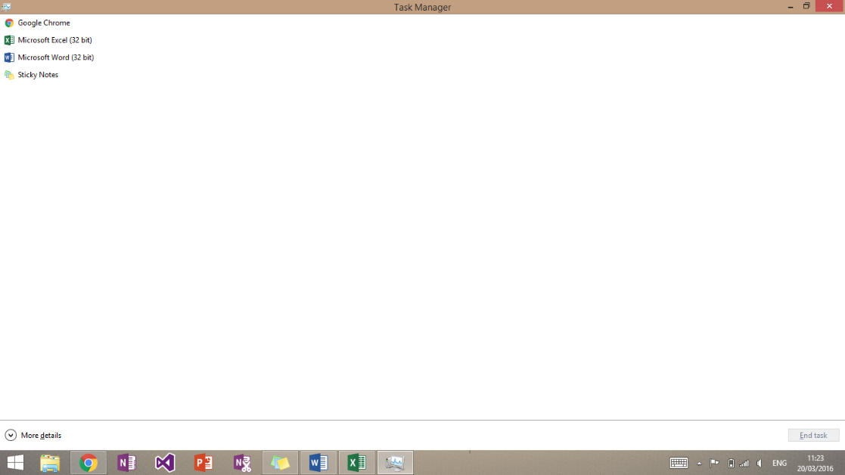To check the performance of this computer I opened up task manager by simultaneously pressing CRTL, SHIFT and ESC.

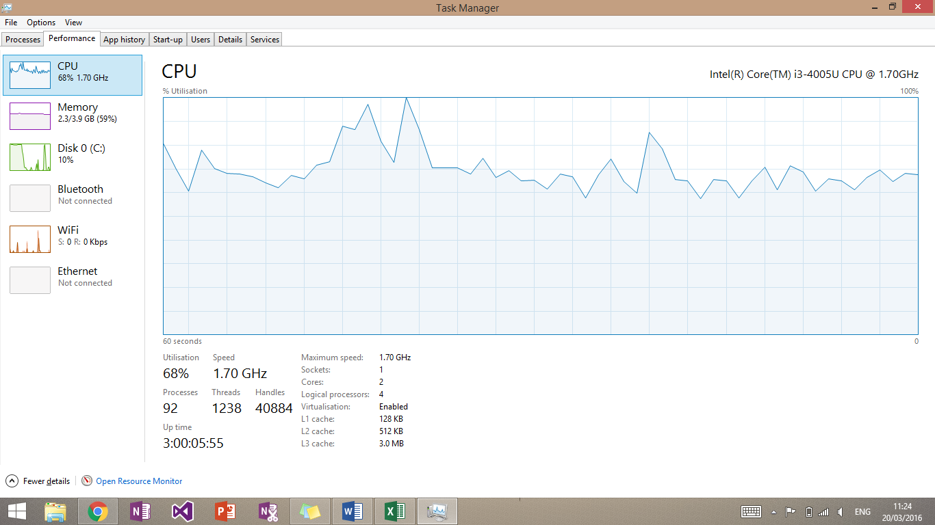This then showed me this screen. This, along with the taskbar, shows what applications I had open. This shows I had Word, Excel, sticky notes and google chrome open. These are applications that typically would be used at the same time in a workplace.

I then pressed more details at the bottom of the page, then the performance tab at the top. This then shows the usage of the CPU over time. In this case, due to the fact that the CPU hits 100% just by viewing task manager with the applications open, I would consider upgrading this CPU. Failure to do so may mean that when an application is doing heavy tasks (i.e. saving) then it may result in this computer crashing. This reduces productivity of the workforce and inevitably loses the company money.

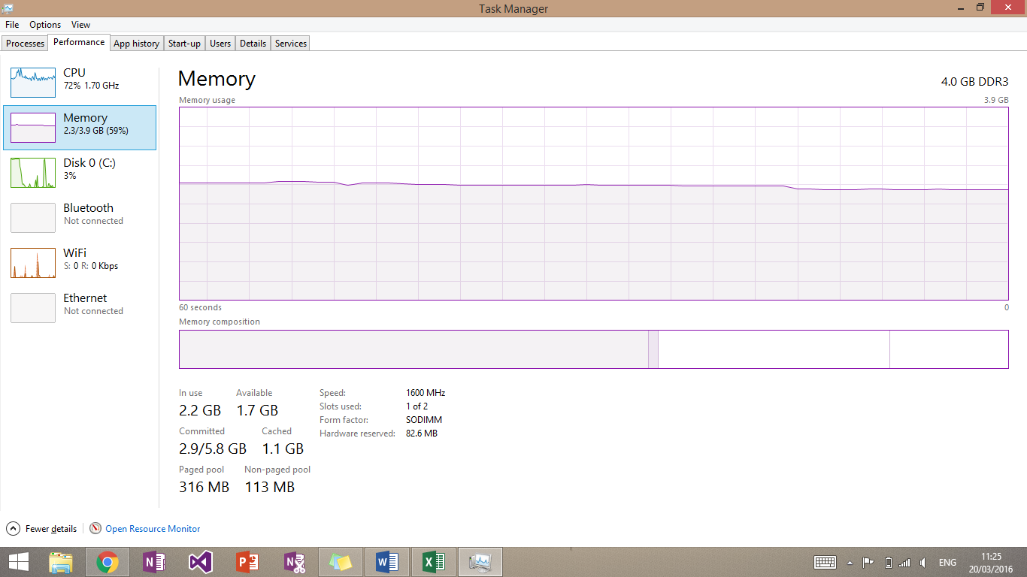The memory is sitting solidly around 60%. This means that there is room for when applications are completing tasks and when more applications are open. I would not recommend upgrading the RAM as its performance is good.

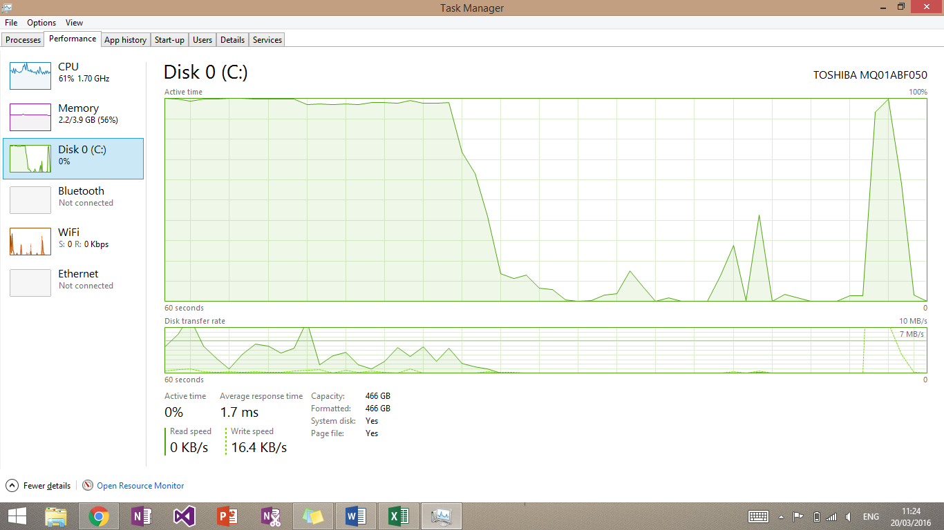

The disk is seen to have spikes on this graph. This is very normal on the disk as it will be opening or writing to files and then doing very little. The fact that the disk is hitting 100% is cause for concern. When this happens a user may find that file editing may become slow or even non-existent. This may result in loss of work again costing the company money.

I would change the boot drive to have and SSD. This separates the boot and file drives so that when they are both being needed they don’t max out. It also means that tasks will happen much more quickly and any effects like the ones detailed above will only happen for a short period of time.

# D2 – Explain and justify improvements to a computer

## Copyright Law

### Limitations imposed by copyright

When you buy software, for example, copyright law forbids you from:

* giving a copy to a friend
* making a copy and then selling it
* using the software on a network (unless the licence allows it)
* renting the software without the permission of the copyright holder
* The law that governs copyright in the UK is called the Copyright, Designs and Patents Act 1988.

### Prevention of software piracy

Software companies take many steps to stop software piracy:

* An agreement between the company that developed the software and the user must be agreed before the software is installed. This is called the license agreement and covers copyright.
* Certain pieces of software require a unique licence key to be entered before the installation will continue.
* Some applications or programs will only run if the media (CD/DVD) is in the drive.
* Some applications or programs will only run if a special piece of hardware called a dongle is plugged into the back of the computer.

## Legal implication of using and editing images

If you find an image online it doesn’t mean that you are ok to use it. If the owner of that image finds that you have used it then he can charge you money and force you to remove it from where you are using it.

If you are using the image for profit then I may cost you lots of money. The owner can claim that the image has made you the money, the image is his and so is the money.

It doesn’t matter whether you are using the whole image or part of it that you have edited it can still get you in trouble. The only way that you can insure no damages is by getting permission from the owner or by using copyright free images.

## Where to find free images

There are a lot of copyright free images online from multiple different websites. These offer free use of the images and no copyright implications. Some may have a small fee for use.

To find these websites I just searched into Google “Copyright free images”. This then showed me lots of websites that offer copyright free images as well as images on google images that are copyright free.

# Appendix

http://www.bbc.co.uk/schools/gcsebitesize/ict/legal/2copyrightrev1.shtml